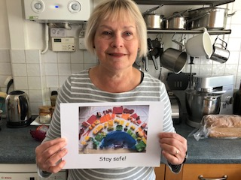

Hello everyone!
I hope you’re all having a good week. I know from your emails and calls that everyone is busy.

From this week there is a part of the Watergate School website just for Blue Class (although we don’t mind if other people look at it too!). Each week there will be ideas of things you might like to try at home – something to think about and do, something to make or listen to and a recipe to try. If you have any good ideas that we can share here, please email me to let me know.

Don’t forget – there is also our book this term ‘Monkey Puzzle’ to look at and lots of activities connected with that too. They were in the envelope I sent you recently. How are you getting on with your Animal Art Gallery, I wonder? Don’t forget to be doing lots of moving too – either your Move programmes or keeping up with Joe Wicks on YouTube.

Have a great week and let me know what you do please.

Love Barbara xxx

b.nathan@watergate.lewisham.sch.uk

