Planting seeds
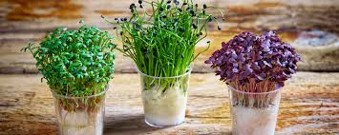

This week we are going to plant some mustard seeds.
You will need:
- A container like a plastic tray, a plastic cup, or even an egg box.
- Kitchen roll (or even clean toilet paper!)
- Mustard seeds (I am sending these to you in the post)

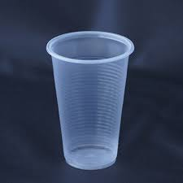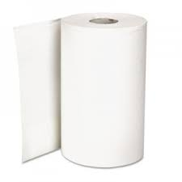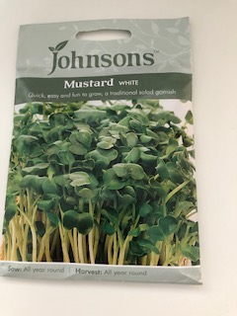

What to do:
- Put some kitchen paper in the bottom of your container.
- Pour water on it so it gets wet. (if you are using an egg box, you need to put some plastic in the box before the kitchen roll so the box doesn’t go soggy).
- Sprinkle some seeds onto the damp paper – you don’t need to use all the packet; you can save some to use another time.
- Put your seeds in a sunny place.
- Look at them and water them every day – don’t let them dry out.
- Soon you will notice little plants growing from the seeds.
- When the plants are tall, you can cut them with scissors.
- What do they smell like?
- What do they taste like?
- You can eat the mustard with egg mayonnaise, in a sandwich or with a salad.

You can watch a video on planting seeds on CBeebies:
https://www.bbc.co.uk/cbeebies/makes/mr-blooms-nursery-cressheads

Here are some ideas of how you can grow your seeds.

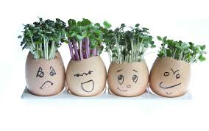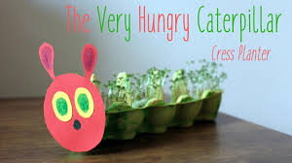
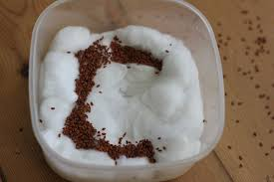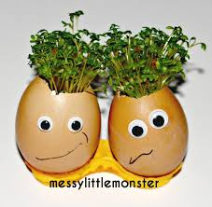

Have fun!

