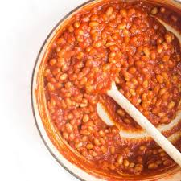
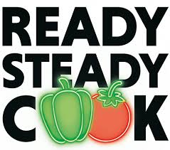
Blue Class
Leanne’s Special Spicy
Beans

Do you remember the yummy spicy beans that Leanne made for us when we celebrated Black History Month last October? Here is her recipe. Thank you Leanne!

Ingredients:
A tin of baked beans
2 tablespoons butter or margarine
2 teaspoons garlic powder
(or more if you like it spicier)
Black or white pepper
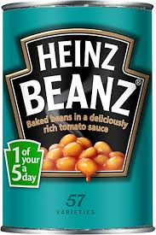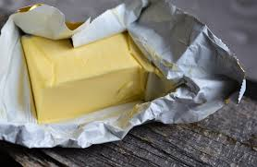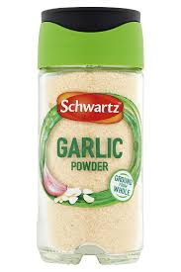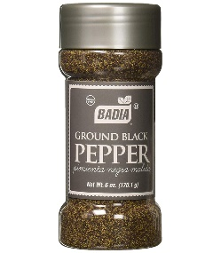

What to do:
- Put everything in a pan and mix together
- Let it bubble up and thicken – careful!! It will be hot!!
- Cook for about 10 minutes
- An adult will need to stir it regularly so the mixture doesn’t stick to the bottom of the pan

You can eat the beans with bread, toast, as they are or with fried dumplings – look out for Leanne’s recipe for these next week.

