Blue Class
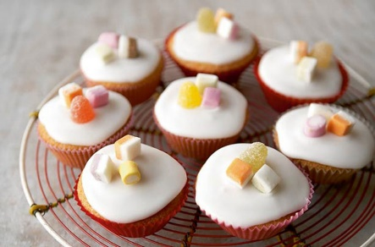
Iced Fairy Cakes
(Mary Berry)
https://www.goodtoknow.co.uk/recipes/mary-berry-s-iced-fairy-cakes

Ingredients: makes 12
Cakes:  100g (4 oz) softened butter  100g (4oz) caster sugar  2 large eggs  100g (4oz) self-raising flour  1 level teaspoon of baking powder | Icing:  225g (8oz) sifted icing sugar  2-3 tablespoons warm water  Sprinkles or small sweets to decorate

What to do:
- Heat the oven to 200C fan/180C fan/gas 6
- Put 12 fairy cake cases into a 12-hole bun tin
- Measure all the ingredients into a large bowl and beat it for at least 2-3 minutes until the mixture is well-blended and smooth.
- Fill each paper case with the mixture.
- Bake in the pre-heated oven for 15-20 minutes until the cakes are well-risen and golden brown.
- Lift the paper cases out of the bun tin and put the cakes onto a wire rack to cool.
- Put the icing sugar into a bowl and gradually blend in the warm water until the icing is fairly stiff.
- Spoon over the top of the cakes and decorate with sprinkle or small sweets.

