1.Shredded sweet potato baked egg nests

INGREDIENTS
- 1 large sweet potato
- 4 eggs
- salt and pepper

INSTRUCTIONS
- Preheat the oven to 400F/200C
- Using a cheese grater, grate the sweet potato into little shreds
- Grease a muffin tin then place the sweet potato shreds into the cups and begin to mold them into little nests
- Once they sweet potato nests have been formed, bake them for 15 minutes
- Remove the nests from the oven, crack an egg into each and sprinkle with salt and pepper
- Bake for an additional 12 minutes, 15 minutes if you want harder yolks

2.Sheet Pan Cheesy Baked Egg Toast
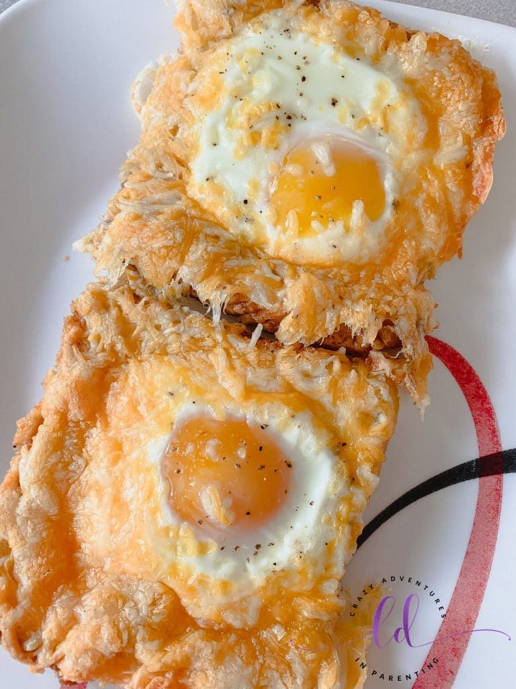

INGREDIENTS
- 4 eggs
- 4 slices of bread
- 1 butter
- 1 bag cheese
- salt and black pepper

- large baking sheet
- small basting brush
- non-stick silicone baking mat
- spatula
- small teaspoon
To get started, preheat your oven to 350F/180C. Lay the non-stick silicone baking mat in your large baking sheet. Spray the edges of your baking sheet with cooking spray (as the bread and cheese will touch the ends). Lay your slices of bread on the silicone baking mat and make it so they fit tight and nicely. You might need to puzzle piece them to get them to fit, but because they are spongy and fresh, they will fit.
Use the edge of your teaspoon to make a rectangle in the bread, pressing down hard to create a “well” where the egg will lay once cracked. Once you create the rectangle, you can use your fingers to ensure the bread is as flat as possible, providing the egg as much room as it needs.
Using a small basting brush, spread softened butter on the bread edges that were not pressed. Because the bread touches in the baking pan, it is easy to do two pieces at a time and get it well and coated. The butter adds a wonderful flavor and helps the cheese stay on the bread.
From here, add your chosen seasonings to both the buttered edges and in the pressed wells.
Crack one egg into each pressed buttered and seasoned piece of bread. Continue for all the remaining pieces of bread. You can add more spices.
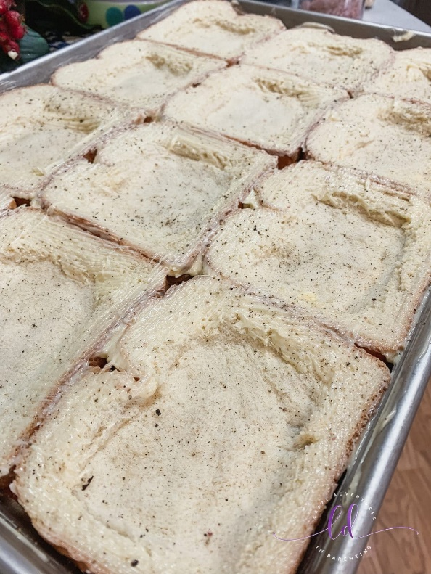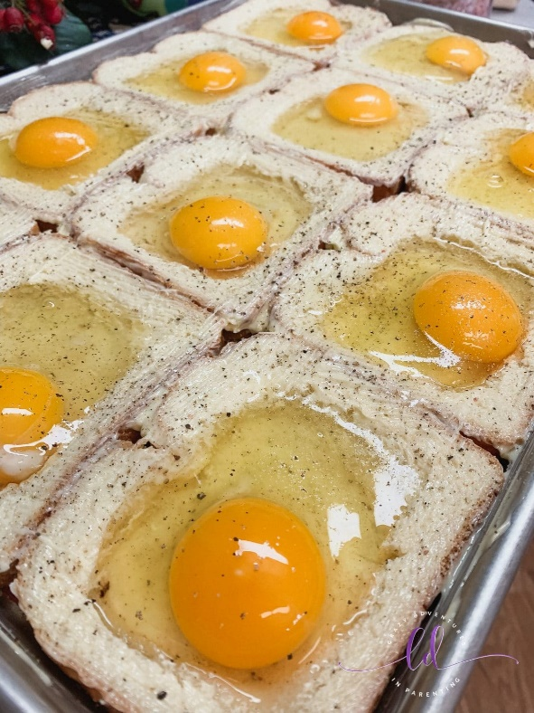
Now’s the super fun part – adding all the cheese! Add the shredded cheese to all the buttered parts, and do it up real nice. The more cheese the better!
Put it in the preheated oven on the top rack and keep it there with the oven light on for about 20 minutes. After that, place it on the bottom rack for the final 10 or so minutes. I live in a high elevation, and it takes about 30 minutes for it to be a semi-fried egg. Depending upon the level of doneness for your eggs, it is going to be finished anywhere between 20-30 minutes.
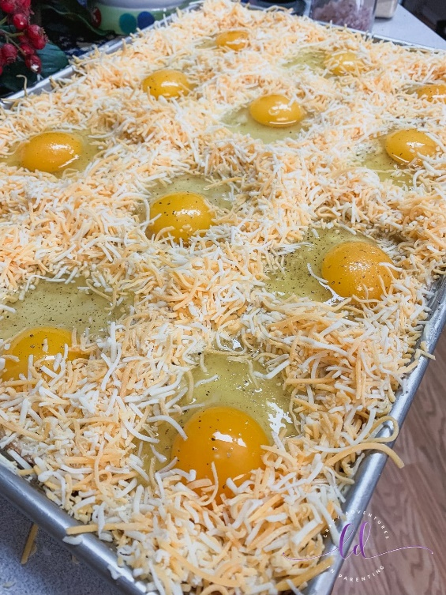
Enjoy!

