Barry the fish with fingers
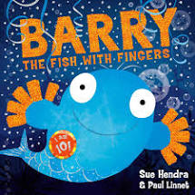
Everyone under the sea is delighted by Puffy, the puffer fish, because he can blow the most amazing bubbles. But what happens when Barry the fish with fingers, swims along……?

You can watch a video of the story here……
https://www.youtube.com/watch?v=Jn1FBkrHNKg

If you have a pot of bubble mixture, why not find it and blow some bubbles?

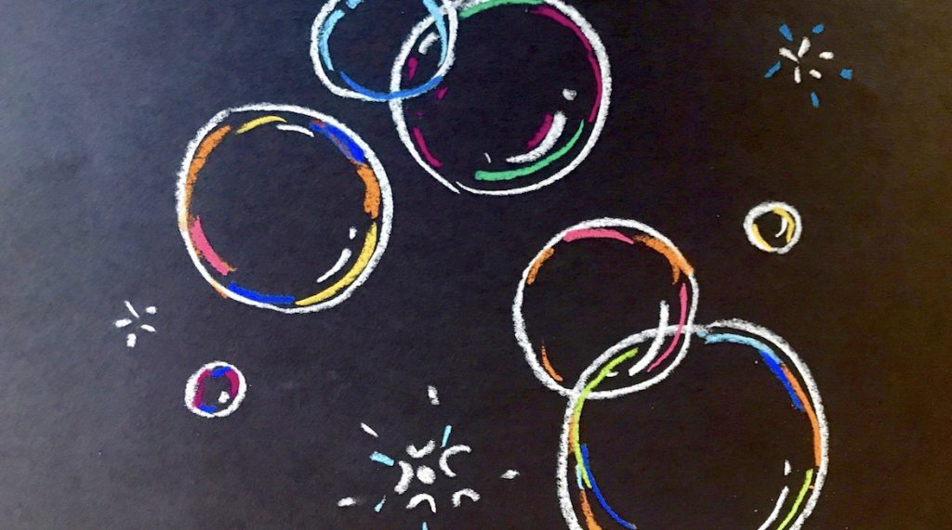

Click below to watch a video of some amazing bubbles!

https://www.youtube.com/watch?v=QseWXpkaGTY

