Chilly creations!

Here’s a great idea from the Play Team at Great Ormond Street Hospital

https://www.gosh.org/power-of-play-hub/games-and-activities/chilly-creations

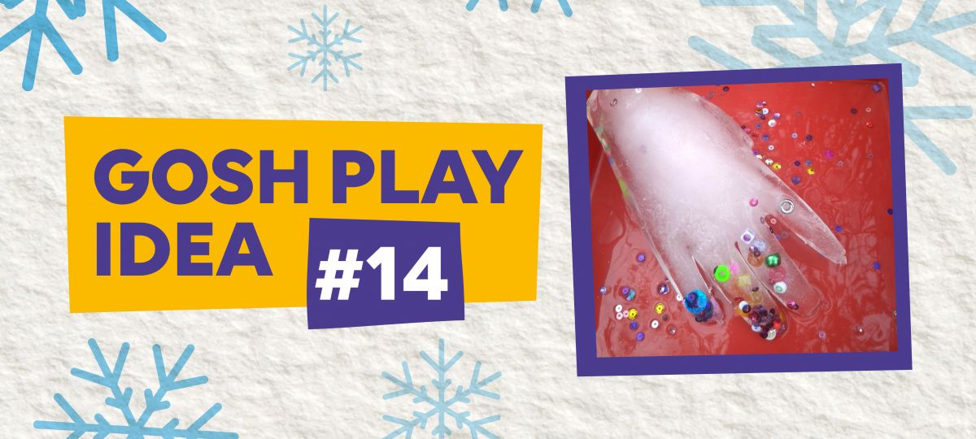

Create your own ice sculptures using everyday objects.

What to do
- Get a tray with a deep base and lots of differently shaped containers – plastic bottles, food containers or even rubber gloves.
- Putting the containers in the tray (to avoid getting water everywhere!) fill each one half full of water.
- Add some extra objects – seashells, flowers, beads, glitter – anything you want. If using a rubber glove, tie an elastic band around the opening to avoid leaks.
- Carefully place in the freezer overnight.
- Once frozen, remove and allow to stand for 20 minutes before letting your children play.

Support from the Play team
“This activity for children of all ages may be the first time ice has been used in play. Many senses will be engaged as they touch the ice. You can use paint brushes to encourage anyone less adventurous to investigate. It’s fantastic for developing their exploration skills, and can bring joy and wonder as they work out what’s hidden.”
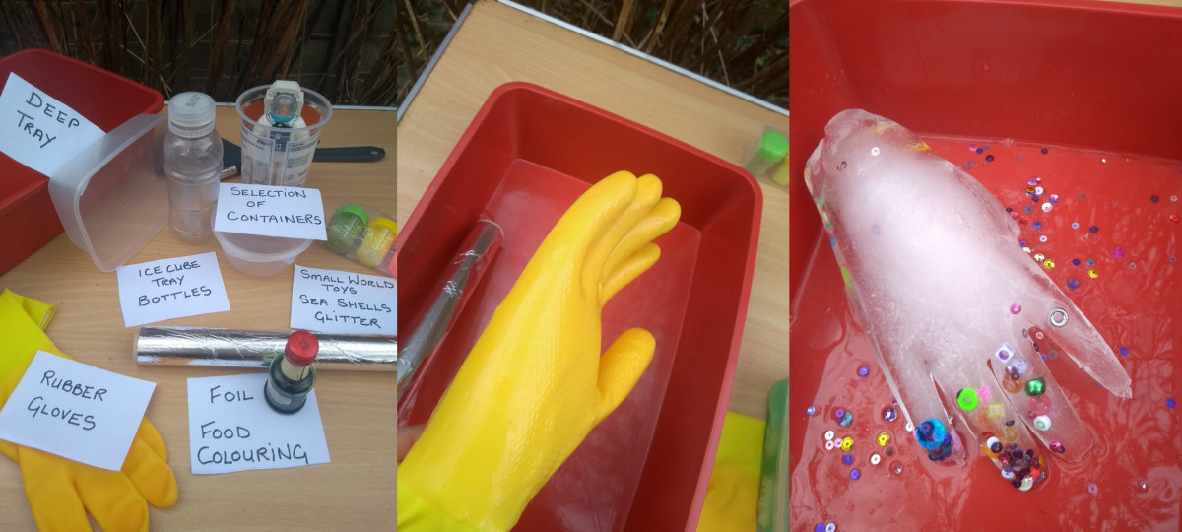

Find some more great ideas here:
https://www.gosh.org/power-of-play-hub/games-and-activities

