Float or sink?

When you go out for a walk, see if you can make a collection of some of these things.
sticks | 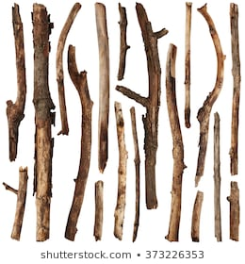
green leaves | 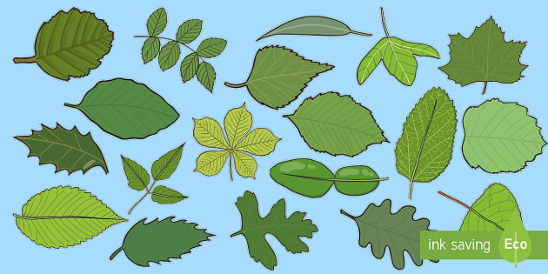
stones | 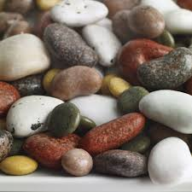
grass | 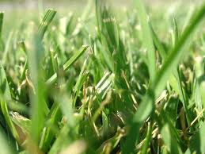
a flower | 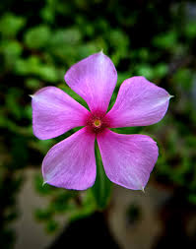
a feather | 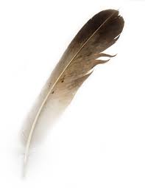
pine cone | 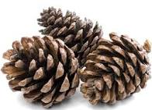
brown leaves | 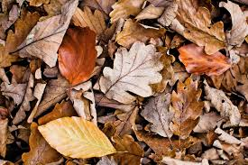
anything else?

When you get home, find a bowl of water (or an adult might let you use the bath!).
Put your objects in a few at a time.
Do they sink (drop to the bottom)?
Do they float (stay on the surface)?
Why do you think they do this?

