Gloves at the ready……

This activity is lots of fun but…… you will get very wet! It’s probably best to try it in the bath (you don’t have to wait until bath-time). If you use a bowl, put a big towel underneath it to soak up some of the water.

You will need some old gloves:
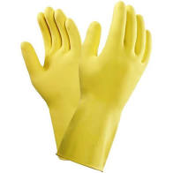 | Rubber gloves
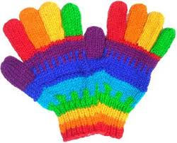 | Woolly gloves
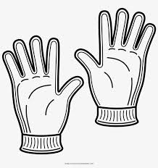 | Other sorts of gloves

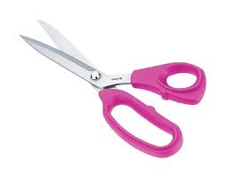 | An adult with some scissor
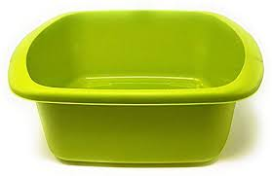 | A washing up bowl
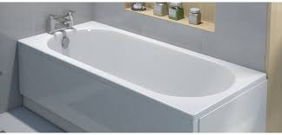 | Or the bath will be even better!

- Ask an adult to use the scissors to make holes or slits in the gloves.
- Make the holes of different sizes.
- Fill the gloves with water.
- What happens?
- How do you get the water out of the gloves with small holes?
- Which are the best gloves to use?

