Have you tried growing any seeds? Send us your photos
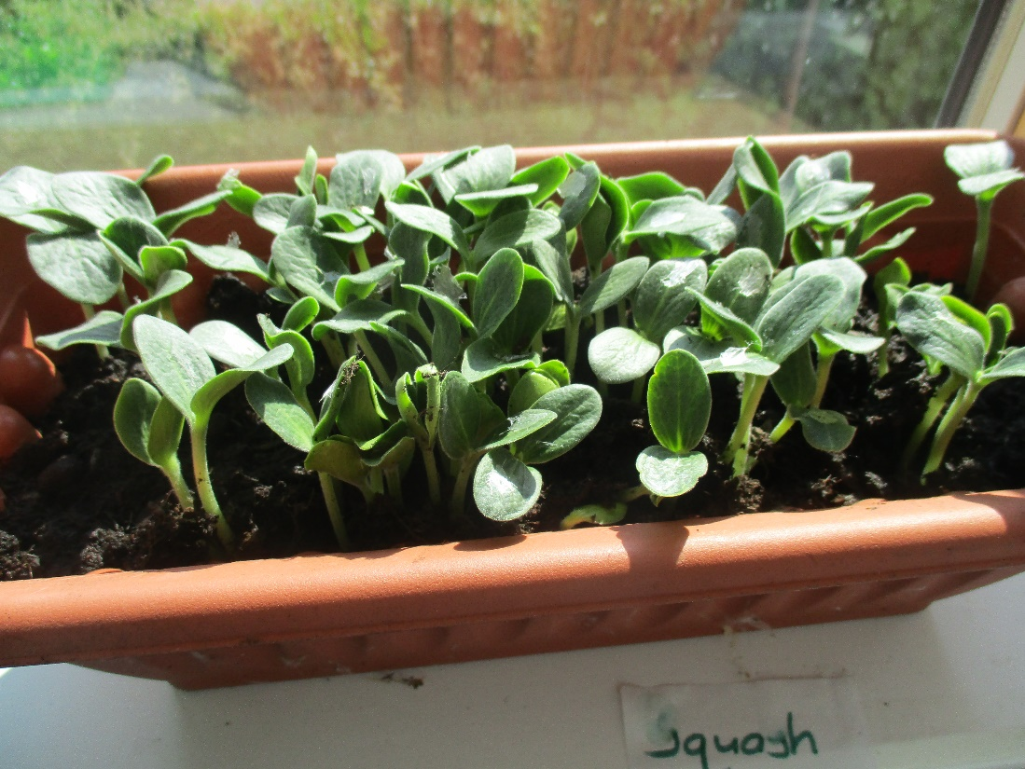
These are our squash seeds after just 5 days!!!
I saved the seeds from home rather than putting them in the compost & look at how they’ve grown
I was THRILLED!! Hopefully you can have a plant by the end of the summer
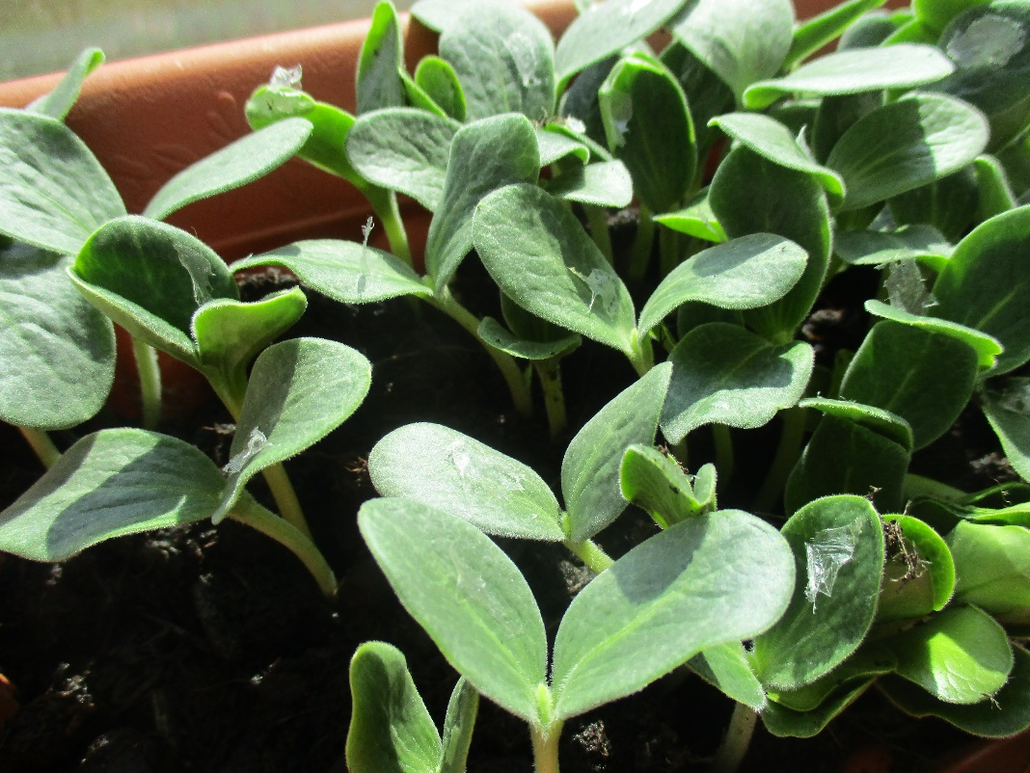

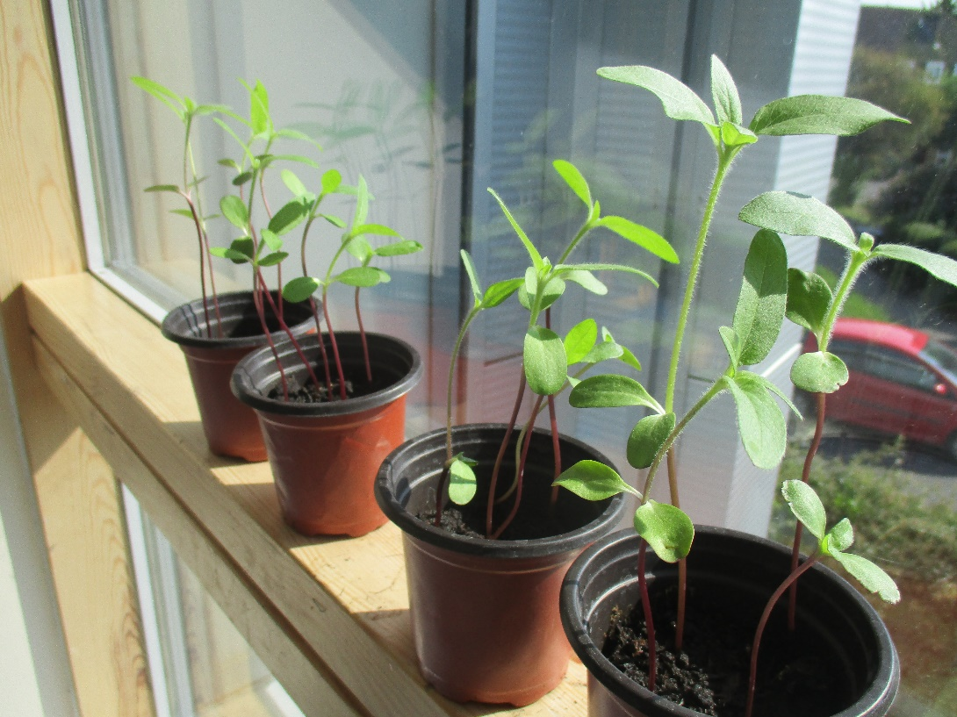
These are our sunflower seeds growing too

