Hello Blue Class!

I hope you have a had a good week. Did you manage to make a fish and try some of the fishy activities we had last week? James made a great fish and sent a photo of it. He also made some fishcakes and added some of the mustard leaves he had grown to the fishcakes. What a good idea – well done James, and thanks for the photos!

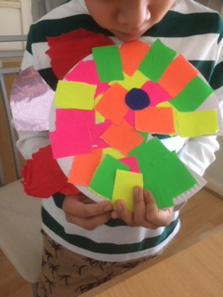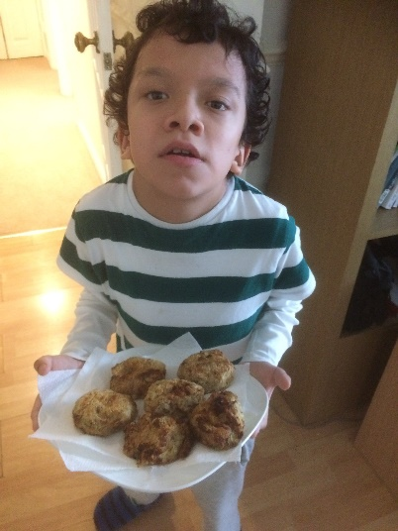

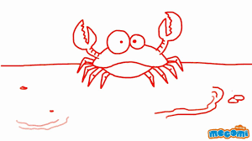
Lots of our activities this week are focusing on crabs. Let’s see what they are……
- Catch a crab – some videos about crabs and some crabby songs

- Make a crab – find paper, card, material, paints and felt pens. Design and make your own crab. There are some ideas here to inspire you.

- Making Tuna Pasta Bake – yummy!

- PE with Olivia – Can you jump like Olivia?
Keep going with your Move programmes.
There’s also some sea creature yoga ideas to try too.

- Ocean playdough – something for you to make and then use.

- Float or sink? – Collect things when you go out for a walk and then use them to have fun with water. You might get wet!

Have a lovely week, everyone, and please let me know what you do, if you can. It’s great to have all your emails and photos, so please keep them coming.

Love
Barbara xxx

b.nathan@watergate.lewisham.sch.uk

