Hello Blue Class!

What have we got on the Blue Class area this week? Let’s look and see……

- Commotion in the Ocean
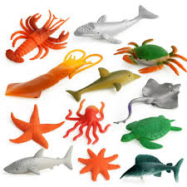
This half term we are going to be thinking about creatures that live under water. There will be suggestions for stories to watch and read together, sea creatures and other things to make, ‘fishy’ recipes, songs, music and much more!
If you have any sea creatures at home, you could find them and use them to play with. They might like to swim in the bath with you!

- Making Easy Fish Cakes – something yummy (and easy!) to cook

- Make an Ocean in a bottle – how can we do that?

- Make an Origami Fish – find a piece of paper, follow the instructions to fold it to make a fish.

- Looking under the Sea

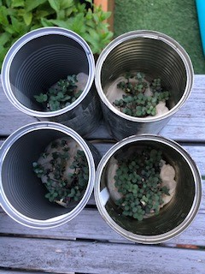
- Did you manage to plant some of your mustard seeds last week? Dylan did and sent me a photo of them growing. It looks as if he was looking after them well and making sure he gave them water each day. Thank you Dylan!

Have a lovely week, everyone, and please let me know what you do, if you can.

Love
Barbara xxx

b.nathan@watergate.lewisham.sch.uk

