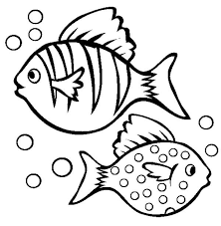
Hello Blue Class!

I hope you have enjoyed looking at Commotion in the Ocean. Were you able to make an ocean in a bottle last week?

Lots of our activities this week are focusing on fish and water. Let’s see what they are……
- Make a fish – find paper, card, material, paints and felt pens. Design and make your own fish. There are some ideas here to inspire you.
- Making Easy Fish Cakes – something yummy (and easy!) to cook.
- Make an Origami Fish – find a piece of paper, follow the instructions to fold it to make a fish.
- Looking under the Sea – underwater webcams and videos to look at.
- Toy-washing station – have fun with water. You might get wet!

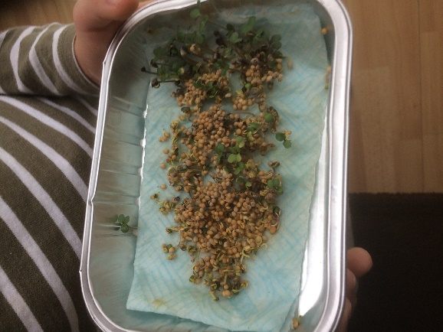
Last week we had a photo of Dylan’s mustard seeds. James has sent a photo of his seeds this week to show you. He has been looking at them in the morning and evening and giving them some water to help them grow. Good growing, James!

Have a lovely week, everyone, and please let me know what you do, if you can.

Love Barbara xxx
b.nathan@watergate.lewisham.sch.uk

