Make a jellyfish
Find some paper, cardboard (cereal boxes or paper plates), paint, felt pens and make a jellyfish. Get all your family busy too. Here are some ideas……
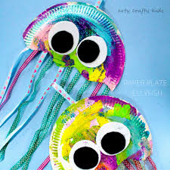 | Paper plate or circle of card.  Coloured paper (you could perhaps use wrapping paper or coloured pages in magazines) for the tentacles.
These are made from paper bags. | 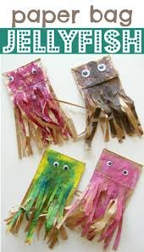
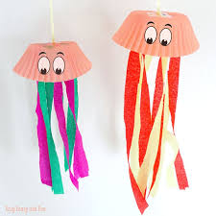 | These are made from muffin cases.
This is another paper plate jellyfish. | 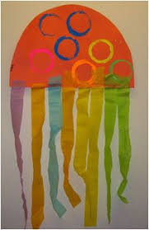

If you have some playdough, try using that to make a jellyfish.

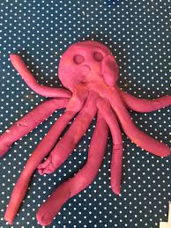

Have fun!

