**Ocean foil painting**

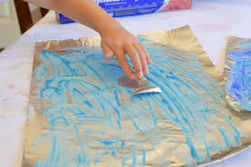 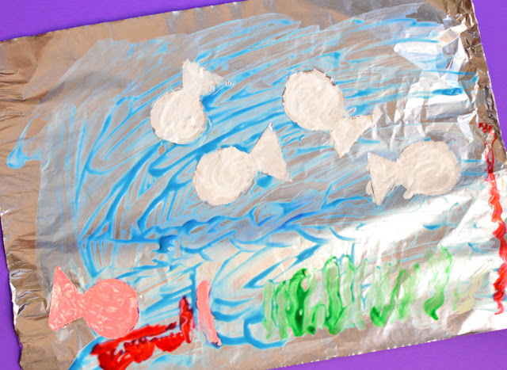

|  |  |
| --- | --- |
| **You will need:**   * Foil * Cardboard (like a cereal packet) * Blue, green and white paint | * Fingers * Paintbrushes * Fish cut out of foil (ask an adult to do this) * Painting apron (or old clothes!) |

**What to do:**

* The cardboard keeps the foil firm, but it doesn’t matter if you don’t have any, just be careful the foil doesn’t tear.
* If you have a cereal box, cut off one large side of it.
* Tear off some foil and press it over and around the edges of the cardboard so that you can see the shiny side.
* Squirt a little bit of paint onto the foil.
* Swirl it around with your fingers or paintbrush.
* Add some more paint until your foil looks like an ocean.
* Put some of the foil fish onto the ocean.

There……finished! Well done!

|  |
| --- |
| TIP: You don’t have to paint an ocean as painting on foil is fun!  You can use other colours of paint. |