Cold water Ocean Playdough
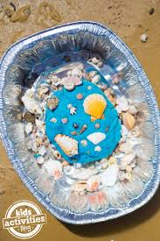
You will need:  2 cups of flour  1 cup of salt  1 tablespoons of vegetable oil  Blue or green food colouring  Blue or silver glitter (if you have some) | 1 cup of cold water  Shells, pebbles (you might find some when you are out for a walk) and sea creatures if you have some.

What to do:
- Put the flour, salt and glitter in a bowl and mix together.
- Add a few drops of food colouring to the water.
- Add the water and the oil to the flour and salt.
- Stir it to mix everything in, then put your hands in the bowl to squash and squeeze it.
- Take it out of the bowl and put it on a plate or tray.
- Press shells, pebbles or sea creatures into it.

TIP: Using cold water means that children can mix everything together as safely as possible. Some recipes online use hot or boiling water, so obviously take a lot of care if you use this near child. Check the mixture is cool enough before they handle it.

