Something Special: Aquarium
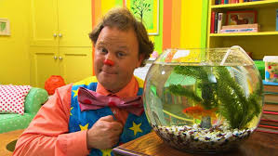

Justin and his friends explore an aquarium whilst Mr. Tumble has a new pet!

Watch here:
https://www.bbc.co.uk/iplayer/episode/b03xpb5q/something-special-were-all-friends-series-9-16-aquarium

