Under the Sea
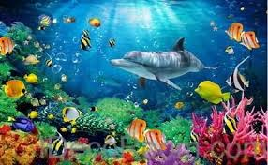

Use the internet to look at creatures under the sea:

Monterey Bay Aquarium – live webcams and pre-recorded videos of life in the Pacific Ocean
https://www.montereybayaquarium.org/

Aquarium of the Pacific
https://explore.org/livecams/aquarium-of-the-pacific/pacific-aquarium-tropical-reef-habitat-cam

Relaxing Underwater Music
https://www.youtube.com/watch?v=cC9r0jHF-Fw

Sing along and dance to ‘Under the Sea’ from Disney’s Little Mermaid
https://www.youtube.com/watch?v=GC_mV1IpjWA

