Sensory Learning
Home Learning Pack

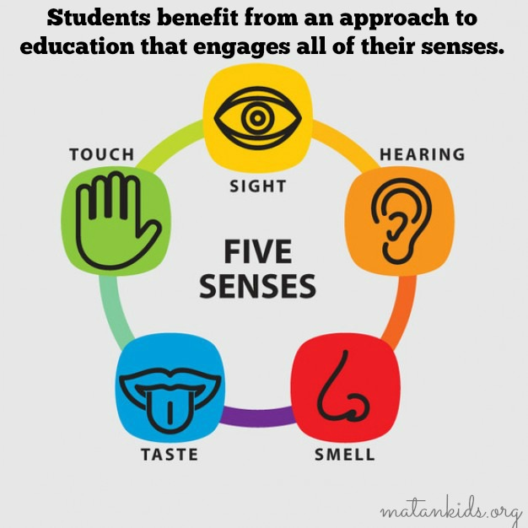

What is Sensory Learning?
Our brains are constantly receiving information about the world via the senses. We rely on this information to understand and engage with our environment. For many of our pupils, the area of the brain which processes sensory information struggles to receive and interpret it. Sensory learning enables our pupils to make more and fresh connections with what is going on around them. Sensory learning unites all of the senses and gives pupils opportunities to access each of them during one activity.

What is in this pack?
This pack includes a range of sensory learning activities which require either no props or props that can either be found around the home.

‘In the Kitchen’ Sensory Journey
General learning objectives:
Pupils will encounter a range of experiences and transfer their attention between each.
Pupils will demonstrate likes/dislikes via facial expression, vocalisation and/or gesture.
Pupils will develop their understanding of cause and effect.
Some pupils may show anticipation skills.
Some pupils may convey whether they want to finish or continue with parts of the session.

For this activity, you will need to use a device which will play the listed music e.g. from YouTube. Play each piece of music for 2-3 minutes. Pause for 10 seconds between each piece.
Props required: rolling pin, chopsticks, spatula, scourer, sponge, foil, flannel
Music | Experience/prop
Game of Thrones Main Theme | Rolling pins
Batucada Samba | Chopsticks
Sing Sing Sing Benny Goodman | Spoons and spatulas
The Booty Swing Instrumental Remix | Bubbles
Enter Sandman Apocalyptica | Scourers
The Quidditch World Cup – Harry Potter soundtrack | Dab with sponges
Korben Dallas – The Fifth Element soundtrack | Foil
Omina Fi-Ra Huri | Drawing circles on pupil
The Fellowship of the Ring – The Black Rider | Dab face with napkin

‘Food Glorious Food’ Sensory Journey
General learning objectives:
Pupils will encounter a range of experiences and transfer their attention between each.
Pupils will demonstrate likes/dislikes via facial expression, vocalisation and/or gesture.
Pupils will develop their understanding of cause and effect.
Some pupils may show anticipation skills.
Some pupils may convey whether they want to finish or continue with parts of the session.

For this activity, you will need to use a device which will play the listed music e.g. from YouTube. Play each piece of music for 2-3 minutes. Pause for 10 seconds between each piece.
Props required: none

Experience | Song
Wave arms when chorus comes (celebrating food) | Food Glorious Food
Patting gently with fists (ice-cream scoops) | I Love Rocky Road
Drawing lines (straws) and then circles (potato chips) | Milkshake and Potato Chips
Tapping quickly with fingertips (beans) | Beans and Cornbread
Drawing squares (bread shape) | Bread and Butter
Squeezing (squeezing limes) | Put the Lime in the Coconut
Drawing spirals (spinning plates) | Be Our Guest
Snatching (lobster claws) | Rock Lobster
Turning/spinning (not knowing where to go) | Lost in the Supermarket

‘The Secret Ingredient’ Sensory Story by Stuart Cummings

Recipe book “Now where’s that recipe book? Ah! Here it is!” They flick feel/flick through recipe book looking at pictures.
It was Anika’s birthday, and Sabrina had promised her she’d make a chocolate birthday cake.
Board or similar hard surface As Sabrina started getting the ingredients out, she heard the pitterpatter of claws on the tiled kitchen floor. Help them to tap the board/surface several times, ideally using their finger nails if possible.
Dog substitute It was her dog Luna. If Sabrina was cooking, Luna would always be there, hoping some crumbs might drop on the floor. “Sorry Luna. It’s not for you!” They stroke “Luna”
Chocolate First Sabrina melted some chocolate. They smell the chocolate.
Large bowl and wooden spoon Then she mixed the flour, bicarbonate of soda, and sugar. They mix the “ingredients” with the spoon.
Small bowl and whisk She whisked some eggs… They pretend to whisk the eggs in the bowl. And mixed everything together.
Oven gloves When the oven was hot, Sabrina poured the mixture into a cake tin, put on her oven gloves, and put it in the oven. They wear the oven gloves.
Icing (+ wipes) Once the cake was cooked and had cooled, Sabrina iced the cake. They feel, smell (and taste if appropriate) the icing.
Packet of pet treats (or similar e.g. chocolate buttons) “Now all I need is some chocolate drops for decoration… Here they are!” They shake the packet.
Party hat Later, at Anika’s party, everybody was wearing a party hat. They wear the hat.
Candle/Torch. Turn lights off. Suddenly the lights went off. Sabrina lit the candle and brought the cake in. Hold candle in front of listener, or torch pointing upwards, if using a candle is not safe.
“Happy birthday to you! Happy birthday to you! Happy birthday dear Anika, happy birthday to you!” she sang.
Candle/Torch Anika blew out the candle. If the listener can blow get them to blow out the candle themselves (if using torch, turn off when they blow). If listener can’t blow, gently blow towards them yourself.
Sabrina cut the cake, and gave the first slice to Anika.
Pet treats “Well, the cake’s lovely!” said Anika. “But what are these chocolate drops? They smell weird…” They smell the pet treats.
Wet sponge, wet wipes or wet flannel “Oh no!” cried Sabrina. “They’re not chocolate drops! They’re Luna’s dog treats! I must’ve used them by mistake! Looks like you get something after all then Luna! Here you go…” Wipe the sponge on the palm of their up-turned hand.
‘Moving Day’ Sensory Story by Stuart Cummings
Preparation – Roll up the “poster” and put a rubber band around it near one end.
Finally it was here. Moving day! Leanna was finally getting her own room.
Set of keys Dad opened the door. “I’ve got the keys!” he said excitedly. They shake the keys. Put these in the jacket pocket without the listener noticing if possible!
Cardboard box “Haven’t you packed yet Leanna?” asked Dad. “Better get started! Here’s a box.” They feel the cardboard box.
Shoe Leanna started packing. She packed her shoes. They feel the shoe and put it in the box.
Book She packed her books. Get them to flick the pages of the book, or do this for them so they can feel them flicking past, then they put it in the box.
Poster/rubber band She rolled up her poster and put a rubber band around it. They feel the rolled up poster, then help them to slide the rubber band down to halfway.
Jacket Soon everything was packed. “Phew!” said Dad. “All that packing’s made me hot, so he took his jacket off and threw it on the back seat of the car. Throw them the jacket.
When they got to the new house, Dad went to open the door. “Oh no!” he said. “I must have packed the keys!”
Aftershave/scrap of paper They started looking through the boxes. They found Dad’s aftershave… Spray some aftershave on the paper for them to smell.
Phone charger They found Mum’s phone charger… They feel the charger.
Biscuit tin And they found the biscuit tin… They shake the tin. If appropriate they can also eat a biscuit! But they couldn’t find the keys!
“They must be here somewhere!” said Dad. “And it’s getting cold now too! Pass me my jacket please, Leanna.”
Jacket/Set of keys As Leanna picked up the jacket, she heard something jingle… They shake the jacket with the keys in. It was the keys! They feel the keys.
Ketchup “I’m so sorry!” said Dad. “Maybe I can make up for it by getting us chips for dinner? After all, I’ve just found the ketchup…” They smell the ketchup.
Action “Don’t worry Dad,” said Leanna. “Chips and ketchup make up for anything!” And she gave him a hug. Give them a hug.

‘A Snowy Day’ Sensory story by Stuart Cummings

Frozen object Leanna was by Callum’s bed when he woke up. “Guess what?! It’s snowed!” she shouted as she shoved a handful of freezing cold snow into his hand. They feel the frozen object.
Screwed up paper Callum quickly put his clothes on and ran out into the snow. He could hear the snow crunch beneath his feet as he walked. They gently squeeze the screwed up paper to the rhythm of footsteps.
Sticks They started making a snowman. “I’ve found some sticks for his arms!” shouted Leanna. They feel the sticks.
Stones “And stones for his eyes and nose!” They feel the stones.
Hat “I think he needs a hat,” said Callum. They put the hat on.
Scarf “…and a scarf!” They put the scarf on.
“Perfect.” said Callum. With the snowman finished, they decided to make snow angels. They lay in the snow, put their arms out to the sides, and moved them up and down to make the wings. If able to, they can lie on the floor and act this out, otherwise just get them to move their arms up and down.
Wet trousers “That was fun,” said Leanna, “but my trousers are soaking wet now!” They feel the wet trousers (or trousers substitute).
Chocolate/cocoa powder “Yeah, mine too.” said Callum. “Let’s go back in and warm ourselves up with a hot chocolate.” They smell the chocolate powder.
Cotton wool or torn up paper “I think that was good timing. It’s snowing again now!” said Leanna. Sprinkle the cotton wool balls or torn up paper on them “Same again tomorrow then?” asked Callum. “Definitely!” said Leanna.

