**Stuck at home? Stuck for ideas?**

**We have activities you can try, all of them are easily resourced from items around the home (or the pound shop!) and will support your child’s development of:**

* **Fine motor skills –** really important for everyday tasks
* **Hand-eye coordination**
* **Shared exploration –** a great opportunity for you to share a fun activity and enjoyment with your child
* **Independent learning through exploration**
* **Communication –** if the activity is motivating – your child will want to ask for more!!
* **Making choices**

**Here are some super sensory play and exploration ideas from our curriculum planners for you to try…**

* Noisy mark making with paint or shaving foam on bubble wrap or tin foil

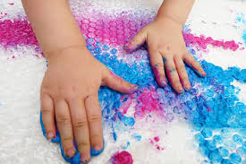 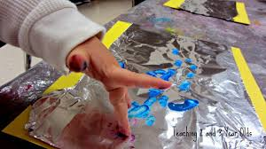

* Shared exploration of motivating activities, e.g.; taking turns enjoying holding, squeezing or poking a sealed freezer bag of paint.

**Flour squishy bag recipe (makes 1 squishy bag)**

· Put a large cup of flour in a bowl and mix it with food colouring (add as much as you wish.)

· Add 5 tablespoons of water and mix together.

· Spoon it into a ziplock bag. Before you fasten it, lay it on a surface and squeeze out the excess air.

**give pupils an opportunity to practice mark-making when positioned on a table/panel.**

 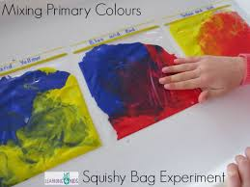

*Sealed freezer bags are a great way of exploring paint and colours for pupils with sensory processing challenges*

* Choosing paints and/or tools (sponge, brush, fork, fingers) to explore and manipulate (e.g.; holding and turning a brush, squeezing and releasing a sponge – grasping and using two hands) in sensory activities, e.g.;

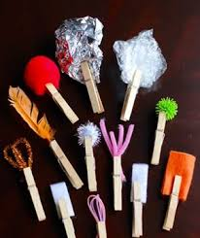 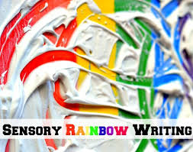 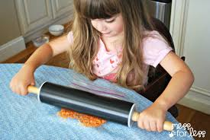

*Different materials/objects in a Shaving foam or corn flour on a Rolling a rolling pin, bottle or tin over*

*peg or taped to a twig is a quick bright surface (or favourite crunchy cereal makes a fantastic*

*and simple way of providing picture sealed in a sound!*

*opportunities to explore sandwich bag)*

*different mark making tools*

*and effects*

* ***Water Play!*** *Bubbly water play with ducks or floating and sinking objects or using a hand whisk to create extra smelly bubbles using bubble bath or washing up liquid. Indeed, just a few cups at the sink or in the bath is a great opportunity for water play!*

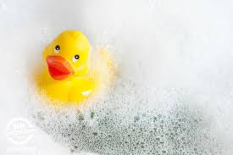 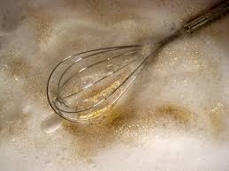

* **Colours and sounds!**

Try exploring shakers (empty bottles filled with different quiet and loud fillings) – picking up, turning, dropping - *as additional challenge, try making them together, giving your child the chance to choose their favourite items and colours to put into the bottle*

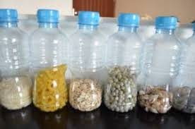 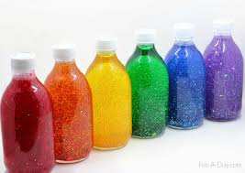

Colourful as well as quiet and noisy items can be attached to an umbrella to provide opportunities for reaching, touching and exploring

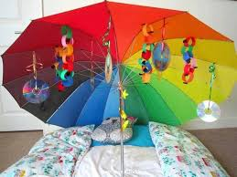

*Rice and pasta can be coloured quickly and easily by adding a few drops of colour to dry rice or pasta, stirring until coated and pop into the microwave for about 30 seconds to 1 minute – leave to cool a bit until warm enough to touch safely!*

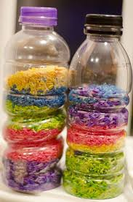 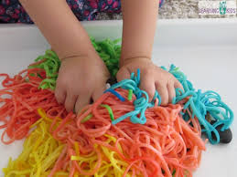 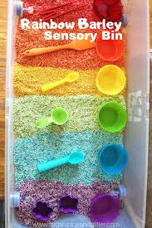

* **Toy Bars**

Toy bars are excellent opportunities for independent play and exploration. To make a toy bar, find something that you can hang items from. This could be something as simple as an umbrella or hula hoop. You could also use a door frame if you have something you can attach items to it with. You could use ribbons, string or anything strong enough to hang something with.

Example items to put on a toy bar:

* Slinky
* Plastic cups, plates and spoons
* Brushes
* Instruments
* Sensory bottles (see previous page)
* Foil
* Bells
* Tissue
* Sponges
* Favourite toys
* Small balls
* Balloons
* Material
* String lights

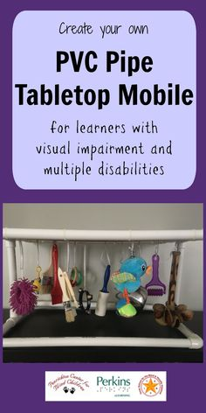 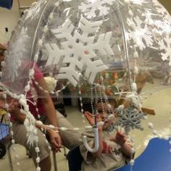 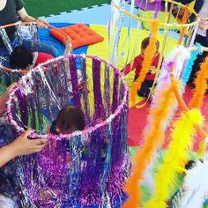

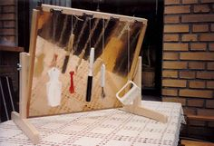

You can also hang items on a mirror so pupils can see as they play with them or have something to bang the items against to make a sound.

* **Fine Motor activities…**

|  |  |
| --- | --- |
|  | *Sensory dough and slime are wonderfully versatile and there are lots of simple DIY recipes online!*  ***Here’s a simple one:***  **2 cups of flour**  ***2 cups of salt***  ***1 cup of water***  ***Mix it all together!***  *Try adding spices and extracts for a super smelly sensory experience!*  *Wraped up, this will keep in the fridge for a few days.* |
|  | Balloons filled with different sensory materials (e.g.; flour, sugar, water, rice, dough) make great home-made squishy balls – decorate them if you feel arty! |
|  | Threading pipe cleaners or straws through holes in a colander |
|  | Threading or posting pasta tubes or cut up straws onto sticks poked into dough |
|  | Building hand strength by pressing kitchen tools – such as a potato masher – into dough |
|  | Using a toy hammer (or rolling pin/spoon/ladel) to crush cereal in a tray – great for fine motor skills and hand-eye co-ordination – as well as being great crunchy, noisy fun! |
|  | Using a punch balloon (available at most pound shops and supermarkets) to develop big and small movements by bouncing it off a hand or foot, catching and throwing, chase games and kicking it around |
|  | Using hand, feet (or spoons if you don’t like getting messy)to find hidden toys or objects in shaving foam or bubbles |
| Image result for oil sensory bottle | Homemade Lava Lamp  Fill one third of a bottle with water - Add a few drops of food colouring and shake - Once colouring is fully mixed with water, fill the rest of the bottle with baby oil or cooking oil - Seal the bottle top - Shake and enjoy! |

Some textures, foods and materials are more challenging for children to explore that others. The tables below give some ideas of textures and foods which are easiest for children to explore and moves up to those which are the most challenging. Each child’s tolerance and acceptance of touching textures will be different.

