Animal Music

Here are links to some of the songs we like in Blue Class. Which animals can you see in them?

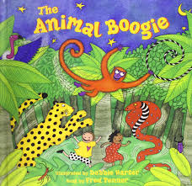 https://www.youtube.com/watch?v=25_u1GzruQM
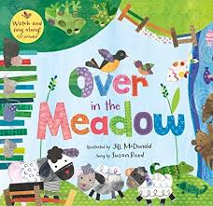 https://www.youtube.com/watch?v=C6ljGXMMB-g
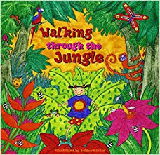 https://www.youtube.com/watch?v=plvY0quSyJg
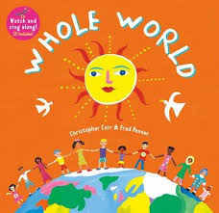 https://www.youtube.com/watch?v=ODftYTD3Rbs

