Make a Thursday night shaker!

On a Thursday night, some of you may be joining in with clapping the doctors, nurses and other people who are working hard to care for us at this time.

Why not make a shaker to shake too? This is what to do:

- Find a clean empty bottle with a lid.
- Look around your home to find something to put inside it to make a noise when you shake it. You could try different things, such as pasta, spaghetti, balls made of cooking foil, straws, sticks or maybe even some spoons if they fit through the top of the bottle. Try to find something that makes a really loud sound!
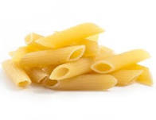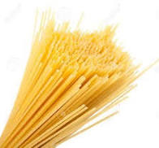
- Put the lid on tightly. You might want to fasten it with sticky tape or glue.
- If you want, you could decorate your shaker with coloured paper, stickers or ribbon.
- Use your shaker on a Thursday night. Shake it really hard and don’t forget to clap too and sign or say

Thank you!

