Hello Blue Class!

I hope you were able to look at the website last week and perhaps try some of the activities.

Alex has sent you a message. She says:
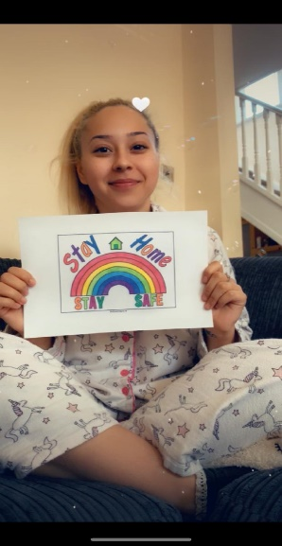
Hello Everyone. I hope you are having a good week and are staying safe and busy!
Miss you all!!
Love from Alex xxx

Sue, Evette, Lisa and Andrea say hello to everyone too and were pleased when I told them that you were all keeping safe.

Leanne has also sent you a message:
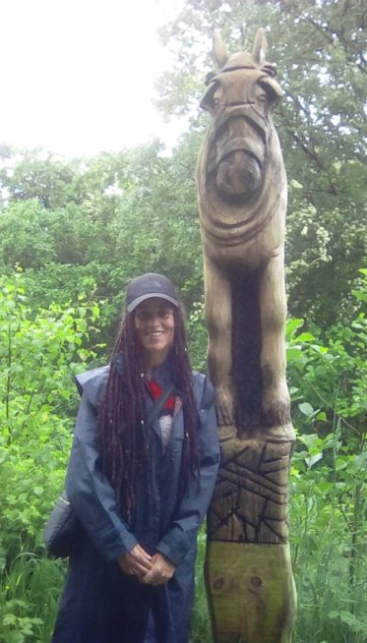
I miss you so much. I can’t wait till we are all back together again, playing with water with lots of bubbles, making big towers from boxes (not forgetting wearing our safety helmets and jackets) – that was fun, wasn’t it Blue Class? Swimming – what fun and how well you are all doing. We are all so very, very proud of each and every one of you. What joy you bring us with how hard you try and do everything we set you. Our hearts are so full of gladness. See you guys real soon. Lots of love, Leanne. Many blessings to you all.

Leanne has given me her recipe for the delicious Special Spicy Beans she made for us last year. You can find that on the Ready, Steady, Cook part of our area.
This week also there is a Scavenger Hunt that you can do around your home. You will have to do lots of thinking! Maybe your family could help too.

There are also links to some of our favourite animal songs we like to listen to in Blue Class.

Please email me to tell me what you are doing and perhaps send photos if you can. Have a good week. Keep busy and stay safe!

Love
Barbara xxx

b.nathan@watergate.lewisham.sch.uk

