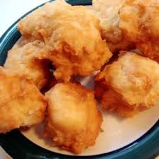
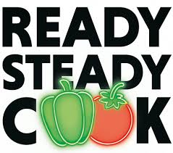
Blue Class
Leanne’s Fried Dumplings

Do you remember the yummy fried dumplings that Leanne made for us when we celebrated Black History Month last October? We ate them with the spicy beans that you had the recipe for last week. Here is Leanne’s recipe for the dumplings. Thank you Leanne!

Ingredients:
- Self-raising flour (Leanne didn’t say how much, so you will have to guess!) (or you can add 2 teaspoons of baking powder to 150g/6oz plain flour if you don’t have any self-raising flour)
- ½ teaspoon salt
- 2 tablespoons of sugar
- Water
- Cooking oil
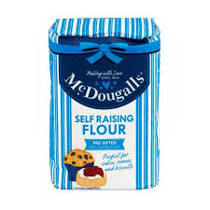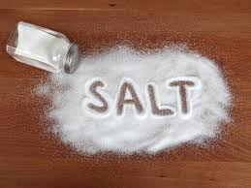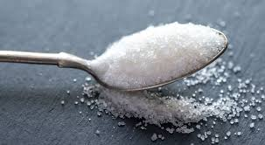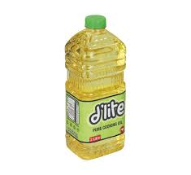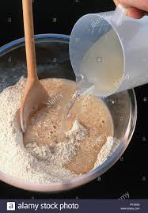

What to do:
- Add the salt to the flour
- Add the sugar and mix together
- Add water gradually until the mixture is a firm dough
- Roll into balls then flatten them out in the palms of your hands
- Put some oil in a deep frying pan on a low heat
- Fry the dumplings on both sides until they are brown (this will be hot, so make sure an adult does this)
- Eat and enjoy!

