Something Special episodes about animals

There are some episodes of Something Special that are about animals. The links are here:
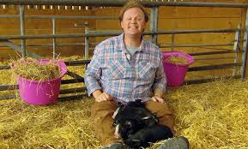 Pig-washing
https://www.bbc.co.uk/iplayer/episode/b03qkw87/something-special-were-all-friends-series-9-1-pig-washing

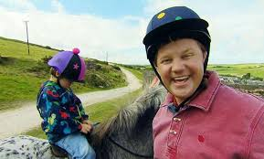 Horse-riding by the sea
https://www.bbc.co.uk/iplayer/episode/b03skfmf/something-special-were-all-friends-series-9-6-horse-riding-by-the-sea

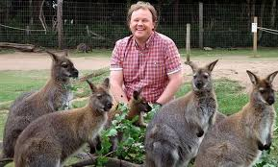 Wildlife Park
https://www.bbc.co.uk/iplayer/episode/b03skn1z/something-special-were-all-friends-series-9-10-wildlife-park

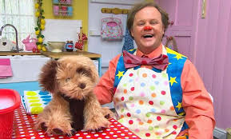 Dog walking
https://www.bbc.co.uk/iplayer/episode/b03tcgl6/something-special-were-all-friends-series-9-14-dog-walking
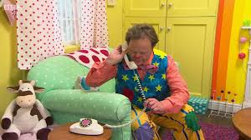 Farm
https://www.bbc.co.uk/iplayer/episode/b03tcgl6/something-special-were-all-friends-series-9-14-dog-walking

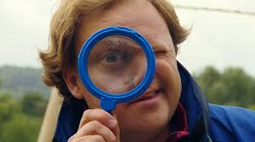 Wetlands Centre
https://www.bbc.co.uk/iplayer/episode/b03ybw6c/something-special-were-all-friends-series-9-25-wetlands-centre

And you might also like to listen to the Spanish songs we enjoy in Blue Class:
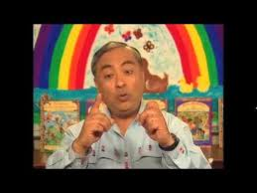
Popular Children’s Spanish Songs by Jose Luis Orozco

https://www.youtube.com/watch?v=oFS1MIh-Pok

