Caterpillar pattern

Colour the caterpillar to make a pattern. You can also use pomp poms, buttons or counters.

|  |
| --- |
| caterpillar patterns (con imágenes) | Juegos sensoriales para ... |
|  |
|  |
|  |
| Pattern caterpillars with pom poms | Preschool patterns, Pattern ... |
| Pattern caterpillars with pom poms | Preschool patterns, Pattern ... |

**Make your own pattern**

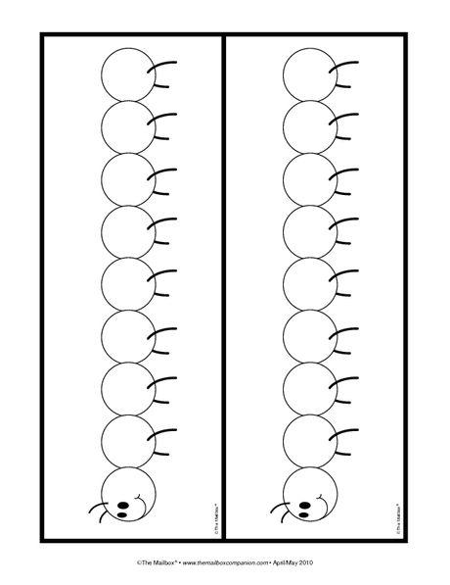



**Find the Missing Numbers**

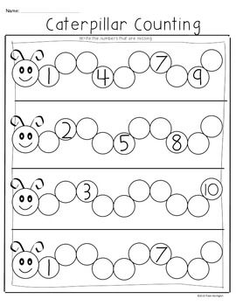

**Write the numbers from 1 to 40. You can also use counters, buttons or pom poms and count along.**

