Catch a crab
This week we are thinking about crabs. Do you remember the crab in ‘Commotion in the Ocean’?
Here are some videos about crabs and other underwater creatures for you to look at.
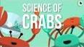 | The Science of Crabs  https://www.youtube.com/watch?v=6oaEF7Kq_64
Grumpy Red Crab song
https://www.youtube.com/watch?v=Hv21pWeUpq4

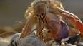 | Hermit crabs  https://www.youtube.com/watch?v=f1dnocPQXDQ&vl=en-GB
Living under the sea song  https://www.youtube.com/watch?v=6oaEF7Kq_64 | 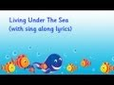
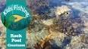 | Rockpools  https://www.youtube.com/watch?v=JtOb6YfqWWo
Happy learning: Fish  https://www.youtube.com/watch?v=TJN3gJoZqlY | 