Community Lunch 2020

One of the highlights of the Watergate calendar is our annual Community Lunch.
It is always a joyful and very tasty gathering of the Watergate community and we are sad that, due to current events, we will not be able to come together to share this with each other this term.

We are going to miss not only the wonderful food that everyone generously brings to share, but the precious time it gives us to spend with each other from our immediate and wider Watergate family.
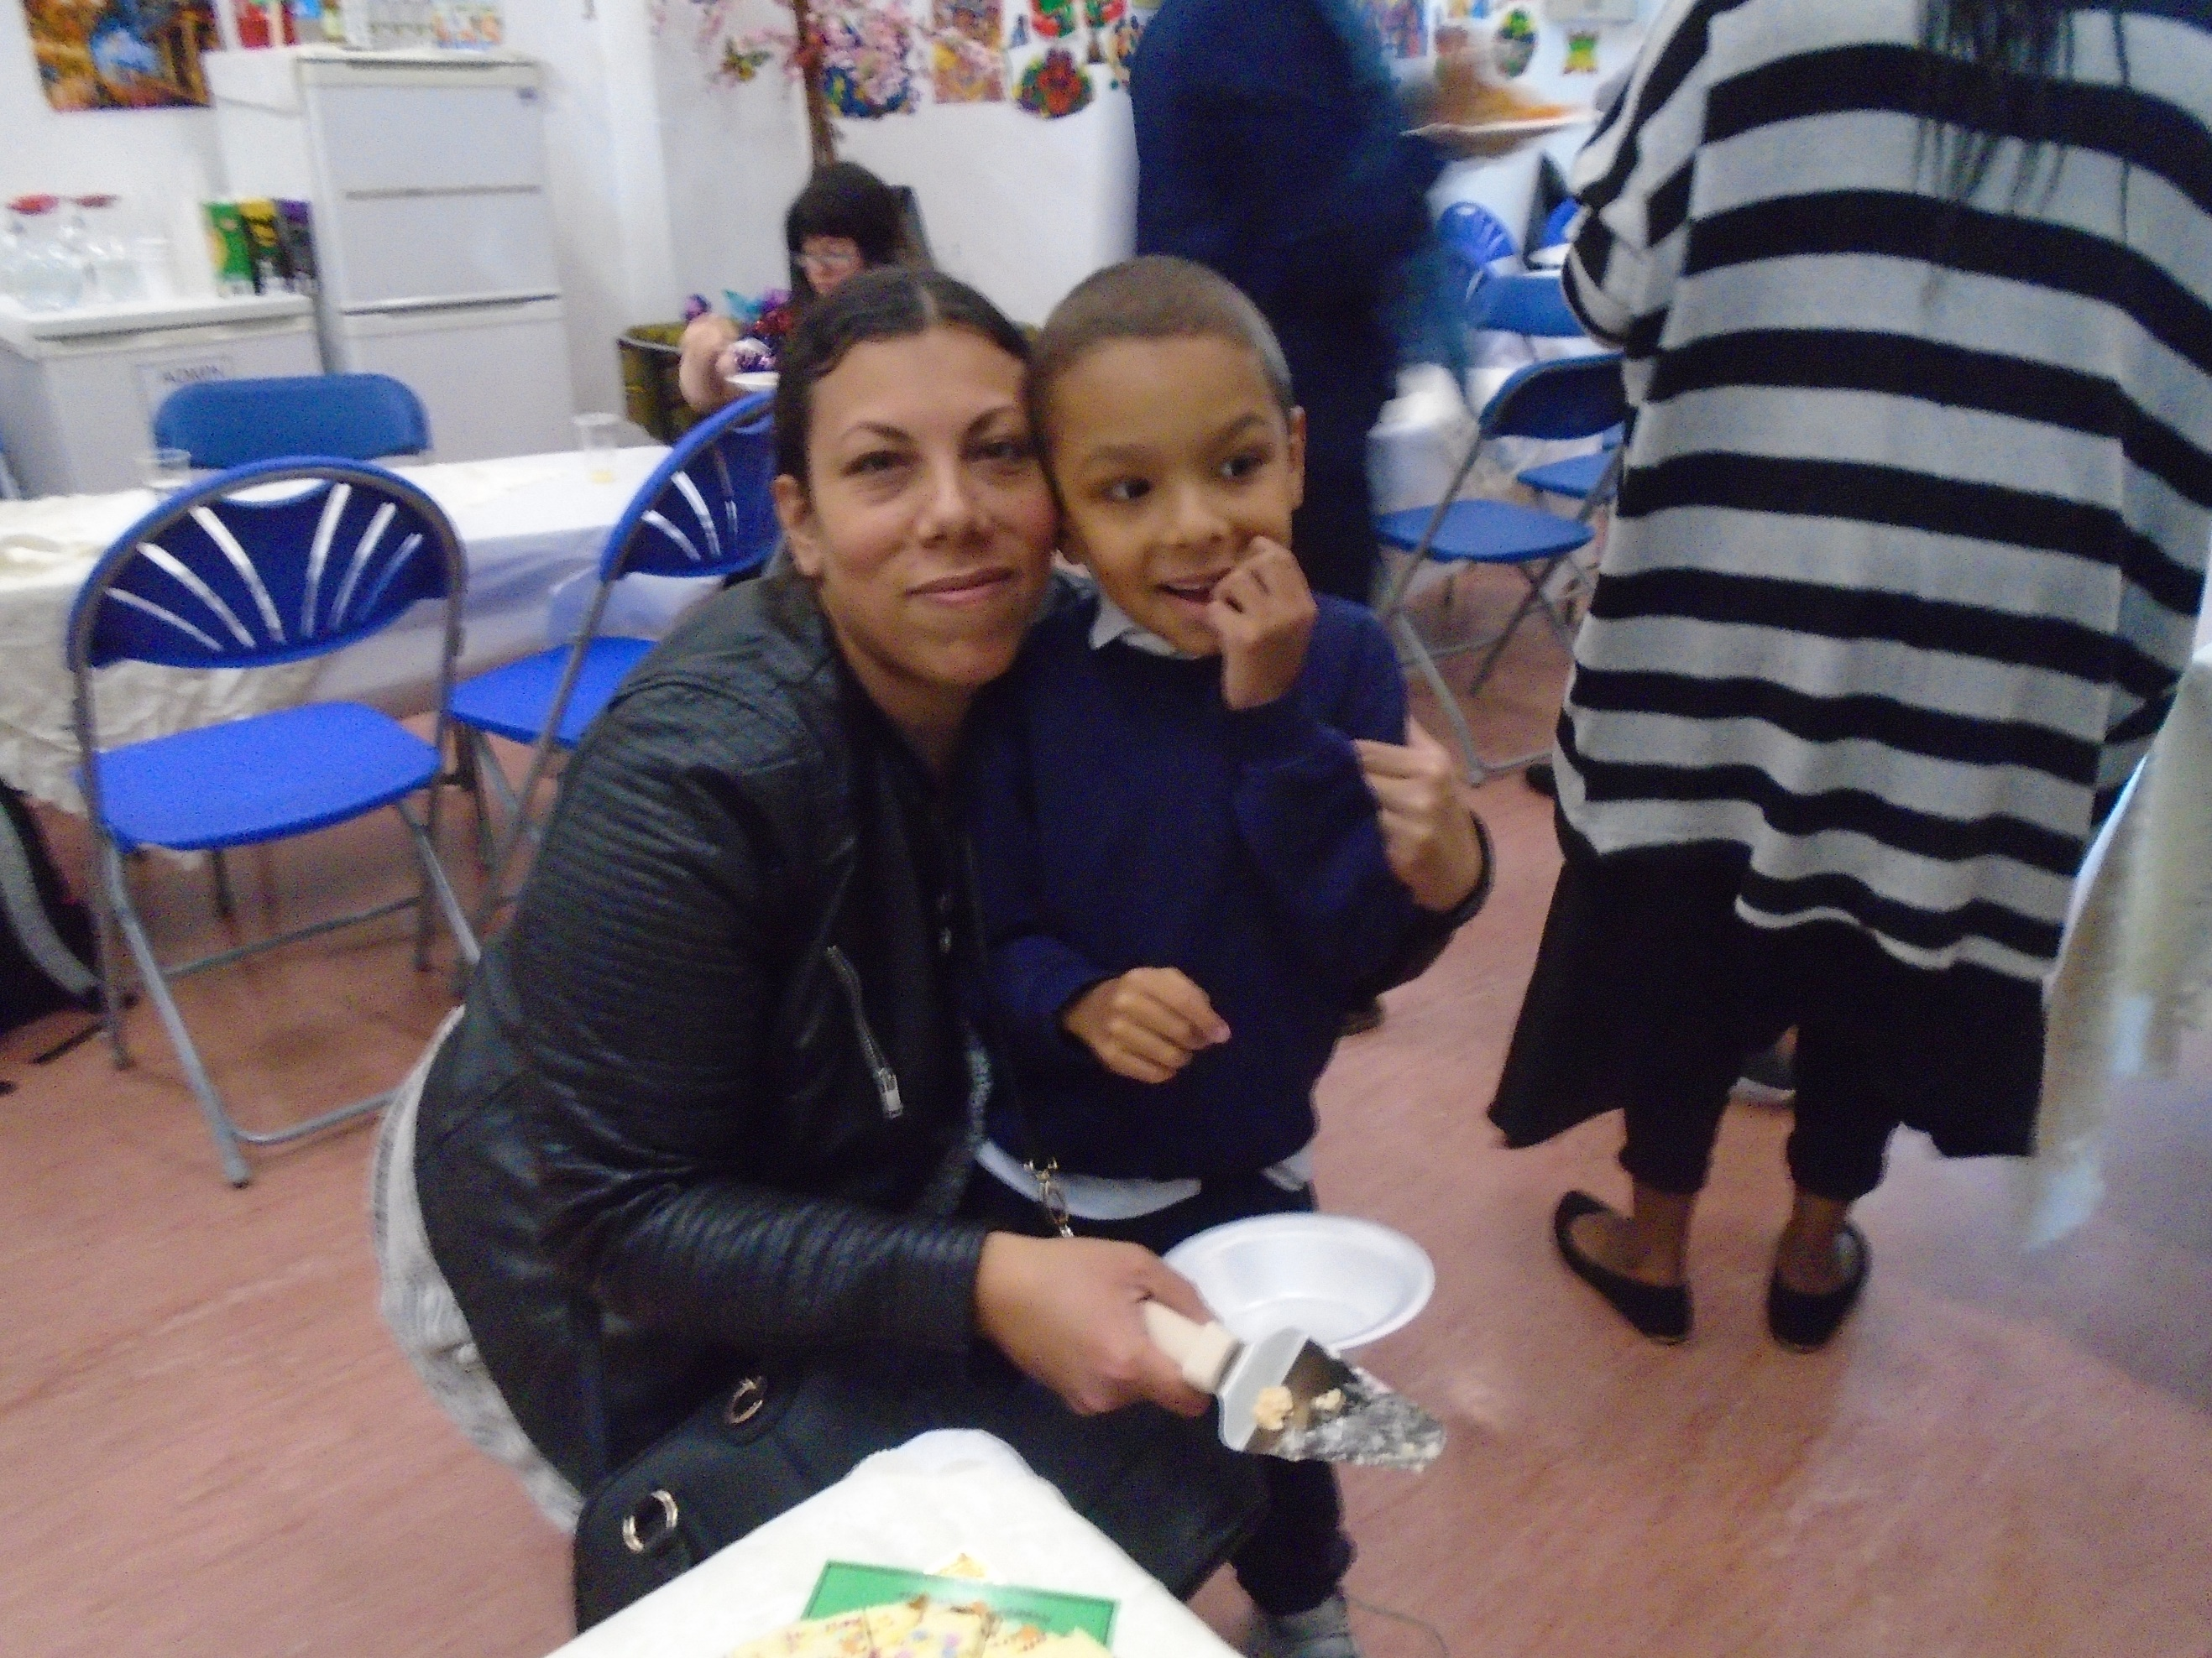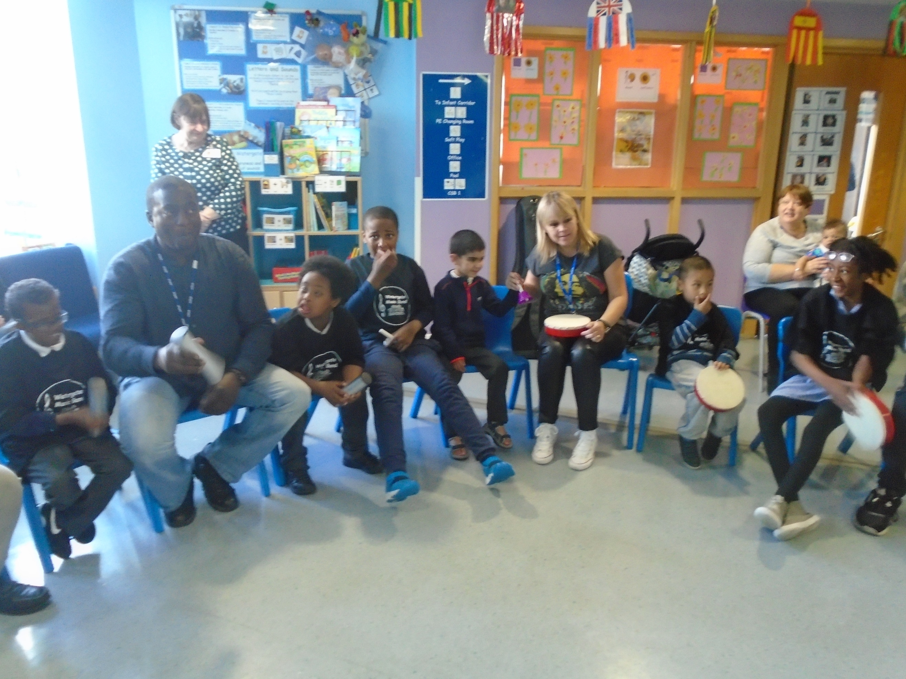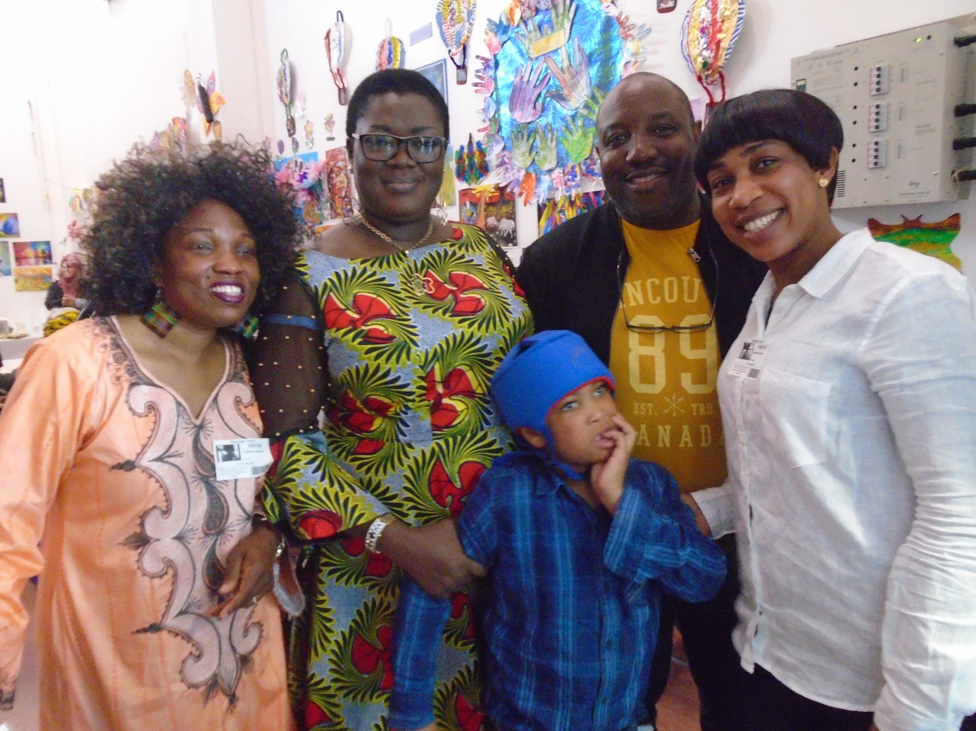
We want to take this opportunity to thank each and every one of you – parents, carers, family, staff, friends, the local community and the Local Authority – for being a valued part of the Watergate community and for continuing to support us during these exceptional times.

We look forward to a time, hopefully later in the year, when we can come together again – reuniting the Watergate community with old friends and new!

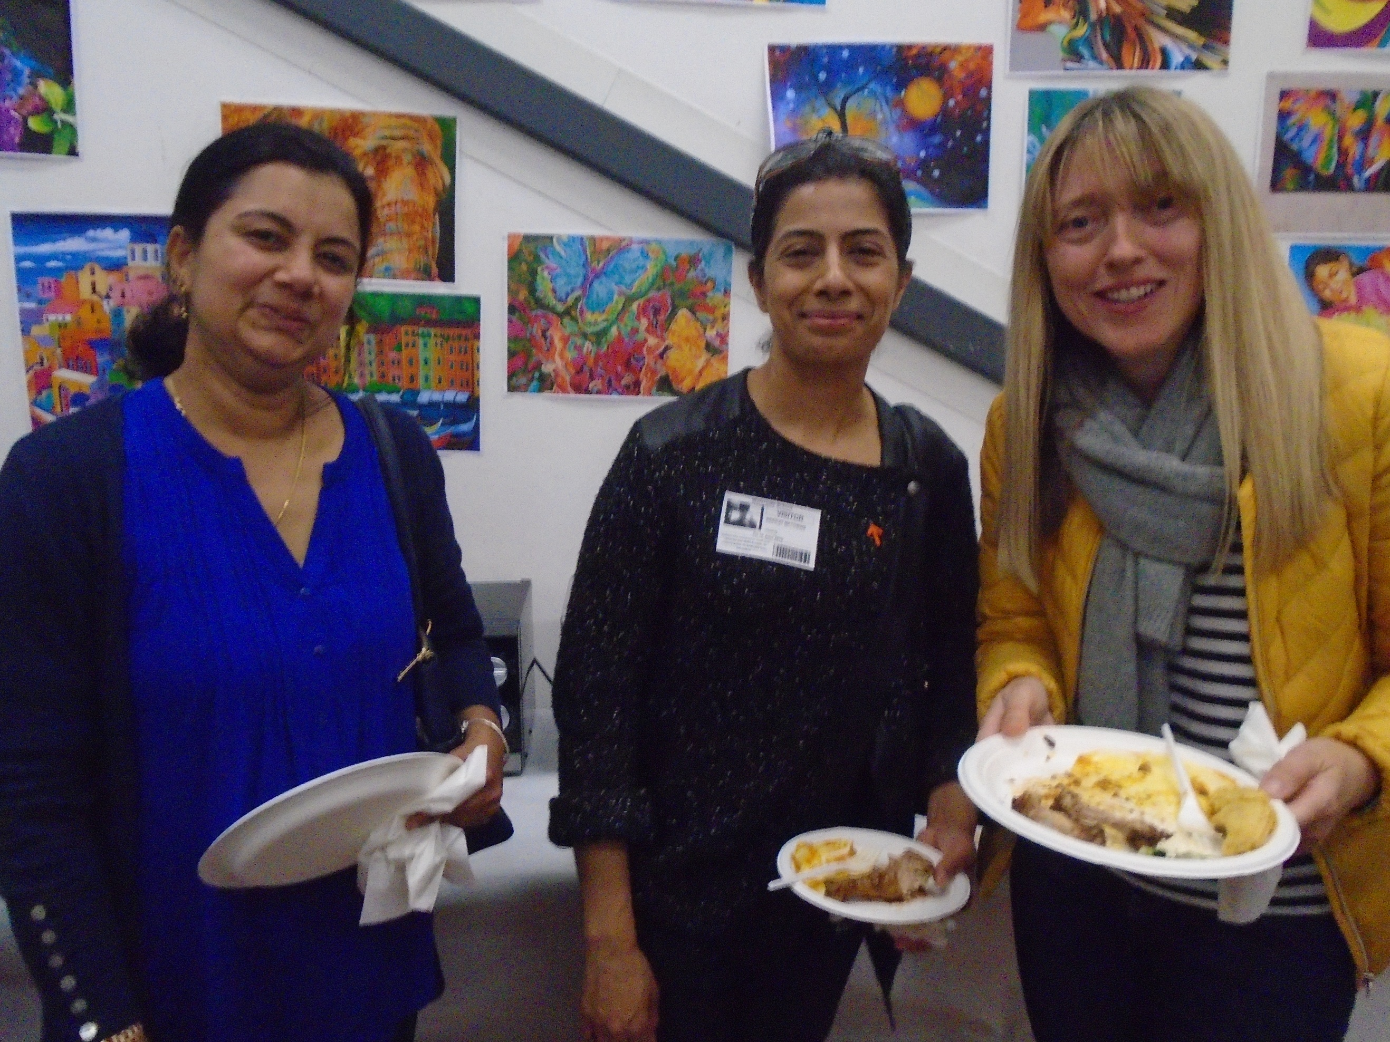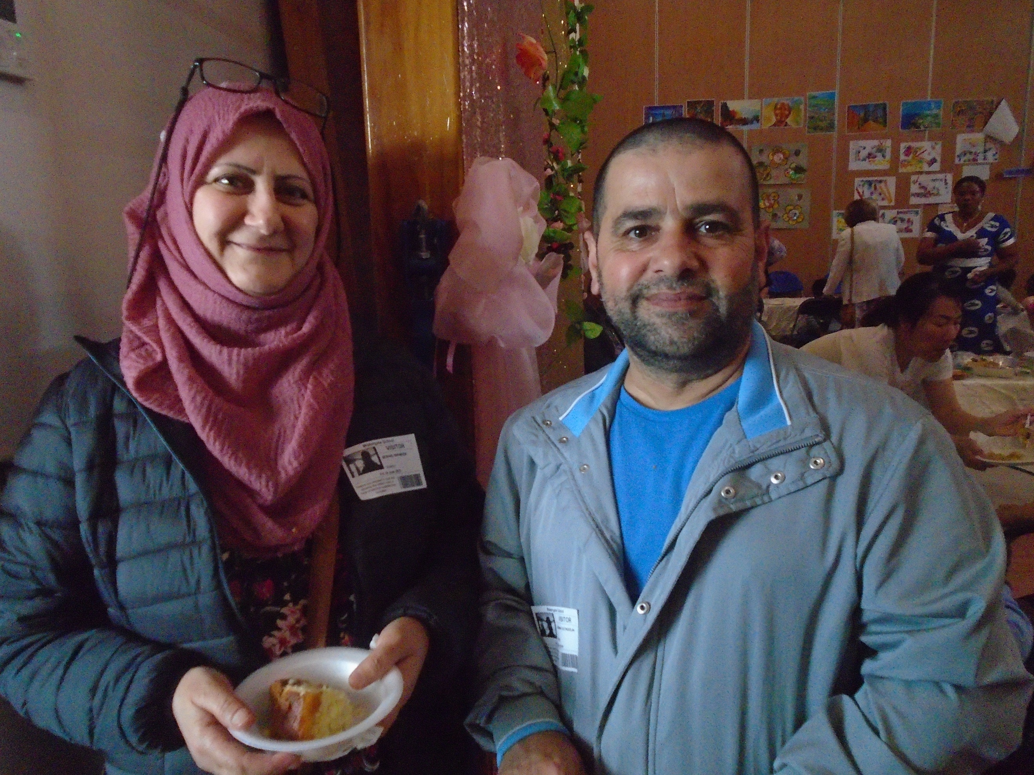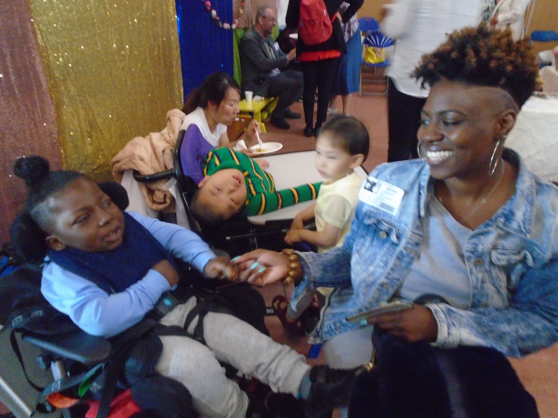

Until then, we wish you all well.

