Find out about Jellyfish
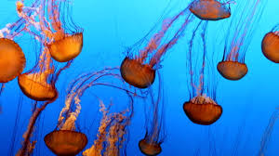

Watch this video to learn about jellyfish.
https://www.youtube.com/watch?v=u9Q9knJlhww

Watch the jellyfish dance!
https://www.youtube.com/watch?v=gFLJSITYf-8

Jellyfish……and more jellyfish!
https://www.youtube.com/watch?v=gdJjc6l6iII

