Hello Blue Class!

I hope you have all had a good week. I emailed Sue, Evette, Leanne, Alex and Lisa to let them know how you all were and what you are up to. They were pleased to hear that you are all well and send you lots of love.

Barry the fish with fingers

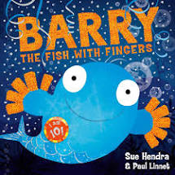

This week we are going to look at a new book called Barry the fish with fingers. There is a video of the book on our website area which you can watch or you can share the story with an adult if you have the book. There’s also a video of some amazing bubbles!

Let’s see what else we have to do this week......

- Ready, steady, cook - Make Crispy Fish Finger Pie - yummy!

- Make a turtle – find paper, card, material, paints and felt pens. Design and make your own turtle. There are some ideas here to inspire you.

- Ocean foil painting – make your own underwater scene.

- Water play – Gloves at the ready! - Be prepared to get wet!

- Something Special – Justin and his friends visit an Aquarium and see lots of creatures that live underwater.

- Relaxing Sea Music

Have a lovely week, everyone, and please let me know what you do, if you can.

Love
Barbara xxx

b.nathan@watergate.lewisham.sch.uk

