Hello Blue Class!

I hope you have had a good week and that you all stayed safe in the sun. It has been so hot!

Some of our activities this week are about jellyfish.

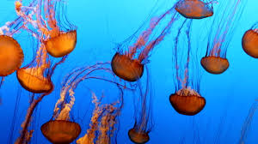

You can watch video to find out some information about them.

Let’s see what there is this week......

Jelly on a plate – make jelly and think about how it changes from a solid, to a liquid and then back again. You can play with it and eat it too!

- Make a jellyfish – find paper, card, material, paints and felt pens. Design and make your own jellyfish. There are some ideas here to inspire you.

- Ready, steady, cook – not jellyfish, but a delicious recipe for fish curry that James and his family have sent.

- Ocean songs – some familiar songs that we like in Blue Class, and one that the rest of the family may know.

- Water play – Chilly Creations – turning water into ice. How does that happen?

Have a lovely week, everyone, and please let me know what you do, if you can.

Love
Barbara xxx

b.nathan@watergate.lewisham.sch.uk

