J is for jellyfish
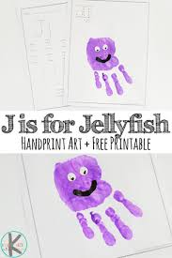

J is for jellyfish…………

How many other words beginning with J can you think of?
Ask your family to think too.
Can you find or draw pictures of some of them?
Maybe someone could write a list……

And there’s another good idea above for making a jellyfish! Use paint or cut-out hand shapes.

