Make a crab
Find some paper, cardboard (cereal boxes or paper plates), paint, felt pens and make a crab. Get all your family busy too. Here are some ideas……
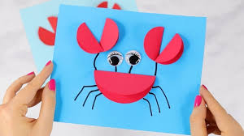 | Use 1 large circle and 4 smaller circles. Fold each in half then stick on another piece of card, Draw legs and eyes.
Find a potato masher and some paint. Print on the paper to make the crab’s body, Use paper to make legs and claws. | 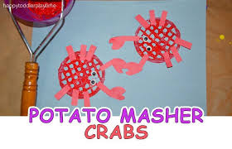
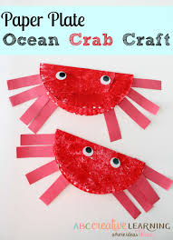 | Find a paper plate or cut out a circle from a cereal box. Paint or colour the circle if you can. When it is dry, fold it in half. Use strips of paper for legs and claws.
Use handprints to make a crab. You could also draw around your hands onto paper or card, cut them out and stick them on another sheet of paper. Draw or make some eyes. | 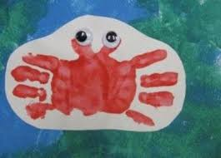

If you have some playdough, try using that to make a crab.

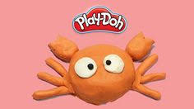

Have fun!

