Make a fish
Find some paper, cardboard (cereal boxes or paper plates), paint, felt pens and make a fish. Get all your family busy too. Here are some ideas……
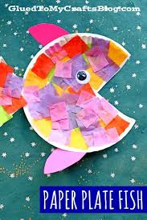 | Paper plate and coloured paper.
Paint your hand and use your handprints to make into fish. | 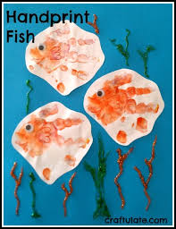
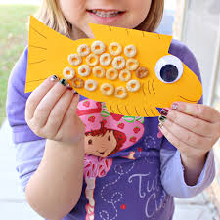 | Find things to glue onto your fish. This one has Cheerios on it!
Draw around your hands to make fish, then attach them to a stick (lolly stick, ruler, rolled up newspaper) to make fish puppets. | 