Make a turtle
Find some paper, cardboard (cereal boxes or paper plates), paint, felt pens and make a crab. Get all your family busy too. Here are some ideas……
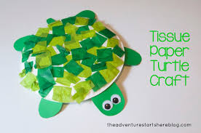 | Paper plate or circle of card.  Coloured paper (you could perhaps find some colored pages in magazines)
Use your potato masher again!  Dip into green paint and print.  Add legs and head. | 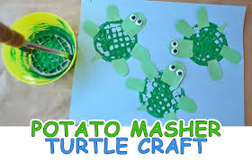
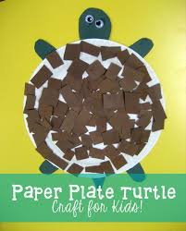 | Another idea using a paper plate.
Make a green handprint or cut out your hand shape to stick on paper. | 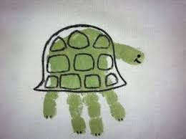
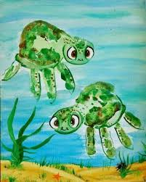 | Make it look as if your turtles are under the sea.

If you have some playdough, try using that to make a turtle.

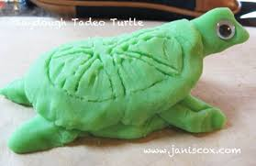

Have fun!

