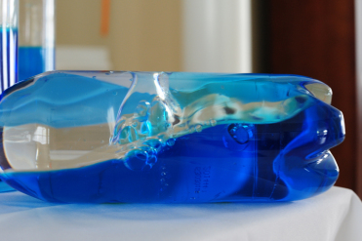
Ocean in a bottle
You will need:
- A clear plastic bottle with a lid
- Water
- Baby oil or cooking oil
- Blue or green food colouring
- Some small pebbles, shells or plastic fish if you have some.

What to do
- ½ fill the bottle with water
- Add a few drops of food colouring – watch the colouring swirl through the water
- Fill the rest of the bottle with oil
- Drop in some small pebbles, shells or plastic fish if they fit in the bottle
- Put the lid on very tightly
- Move your bottle from side to side – can you see the waves inside?
- This happens because the oil floats on top of the water.

Ocean in a bottle videos:
https://www.youtube.com/watch?v=49o2V2TZiow
https://www.youtube.com/watch?v=Pcu286G46Ao
https://www.youtube.com/watch?v=iHh5bPKYe5c

