PE with Olivia
Olivia has learned to jump! Here she is ………great jumping, Olivia!
Don’t forget to look at the daily MOVE activities appearing on the Watergate School MOVE Twitter page at www.twitter.com/movewatergate

There are also some videos here that you might find fun. Make sure you get all your family to join in too!
https://www.youtube.com/watch?v=BrYqWAw8P_8

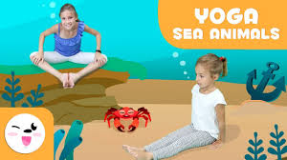
https://www.youtube.com/watch?v=z2UQ5-cVHjs

