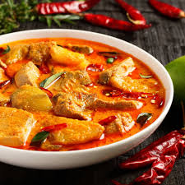
Blue Class

Fish curry

h

James and his family have been doing some great cooking together over the last few weeks. Here’s one of their favourite recipes for Fish Curry for everyone to try. Thank you James, Mummy and Daddy!

Ingredients:
- 500g white fish fillets e.g. cod, haddock
- 300g basmati rice
- 4 large tomatoes, chopped
- 4 tsp curry paste of choice
- Handful washed spinach
- 1 sweet potato, chopped into very small cubes
- 600ml boiling water

Preparation:
- Rinse rice and tip into shallow pan.
- Add curry paste and water.
- Add tomatoes, sweet potato and spinach. Bring back to boil.
- Simmer approximately 20 mins or until rice cooked.
- If wished, stir in tablespoon of crème fraiche.

Enjoy!

