Washing toys

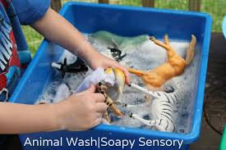

Collect some toys and follow the link below to give them a good wash!

https://www.gosh.org/power-of-play-hub/games-and-activities/washing-station

Tip: if your child has sensitive skin, use their bubble bath or body wash instead of washing up liquid.

Another tip: everything will get wet so think about where to put the tray if you don’t want too much mess – or use the bath!

Have fun!

