Edible Gummy Bear Slime

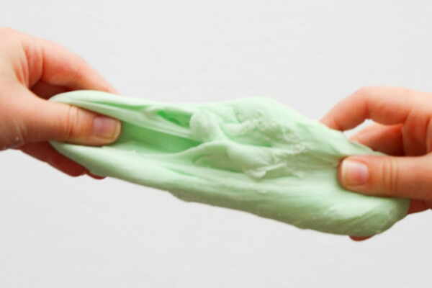
This is great for small hands and fingers to squeeze, squish, stretch and taste!
You will need:
- 1 cup gummy bears
- 2 tablespoons icing sugar
- 2 tablespoons cornflour
- 1 teaspoon coconut oil, optional

What to do:
Heat the gummy bears in the microwave for 10-15 seconds – what happens?
Stir, and reheat as necessary to break down the gummy bear shape
(Be sure to use a microwave-safe bowl and handle carefully).
Stir again, then knead in your icing sugar and cornflour in equal amounts – what’s happening to the mixture now?

Eventually, the gummy bear slime forms a cohesive dough/slime consistency.

The more icing sugar/cornflour you add, the less sticky the slime will be – but also the thicker and less stretchy it will be, so try to find that perfect sweet spot.
If the slime is a bit tacky, have some extra cornflour on hand to coat your hands with. The more you play with any edible slime, the stickier it can get so you may need to add more cornflour/icing sugar to the slime if you find that it’s getting too sticky.
Have fun!

