Find out about the Octopus

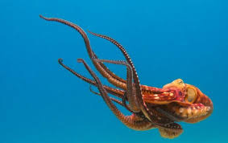

Watch these videos to learn about octopus.
https://www.youtube.com/watch?v=fHRS3bD4yPM

https://www.youtube.com/watch?v=0u6jV9mkFuY

Here’s an Octopus song
https://www.youtube.com/watch?v=JhEbBiVxH9o

Here’s a song your mums, dads and grandparents will probably remember!
https://www.youtube.com/watch?v=De1LCQvbqV4

Join in with the Octopus’s Garden
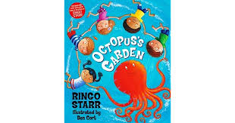

https://www.youtube.com/watch?v=lAeSiM4YTFM

https://www.youtube.com/watch?v=Su-uthlXJN4

