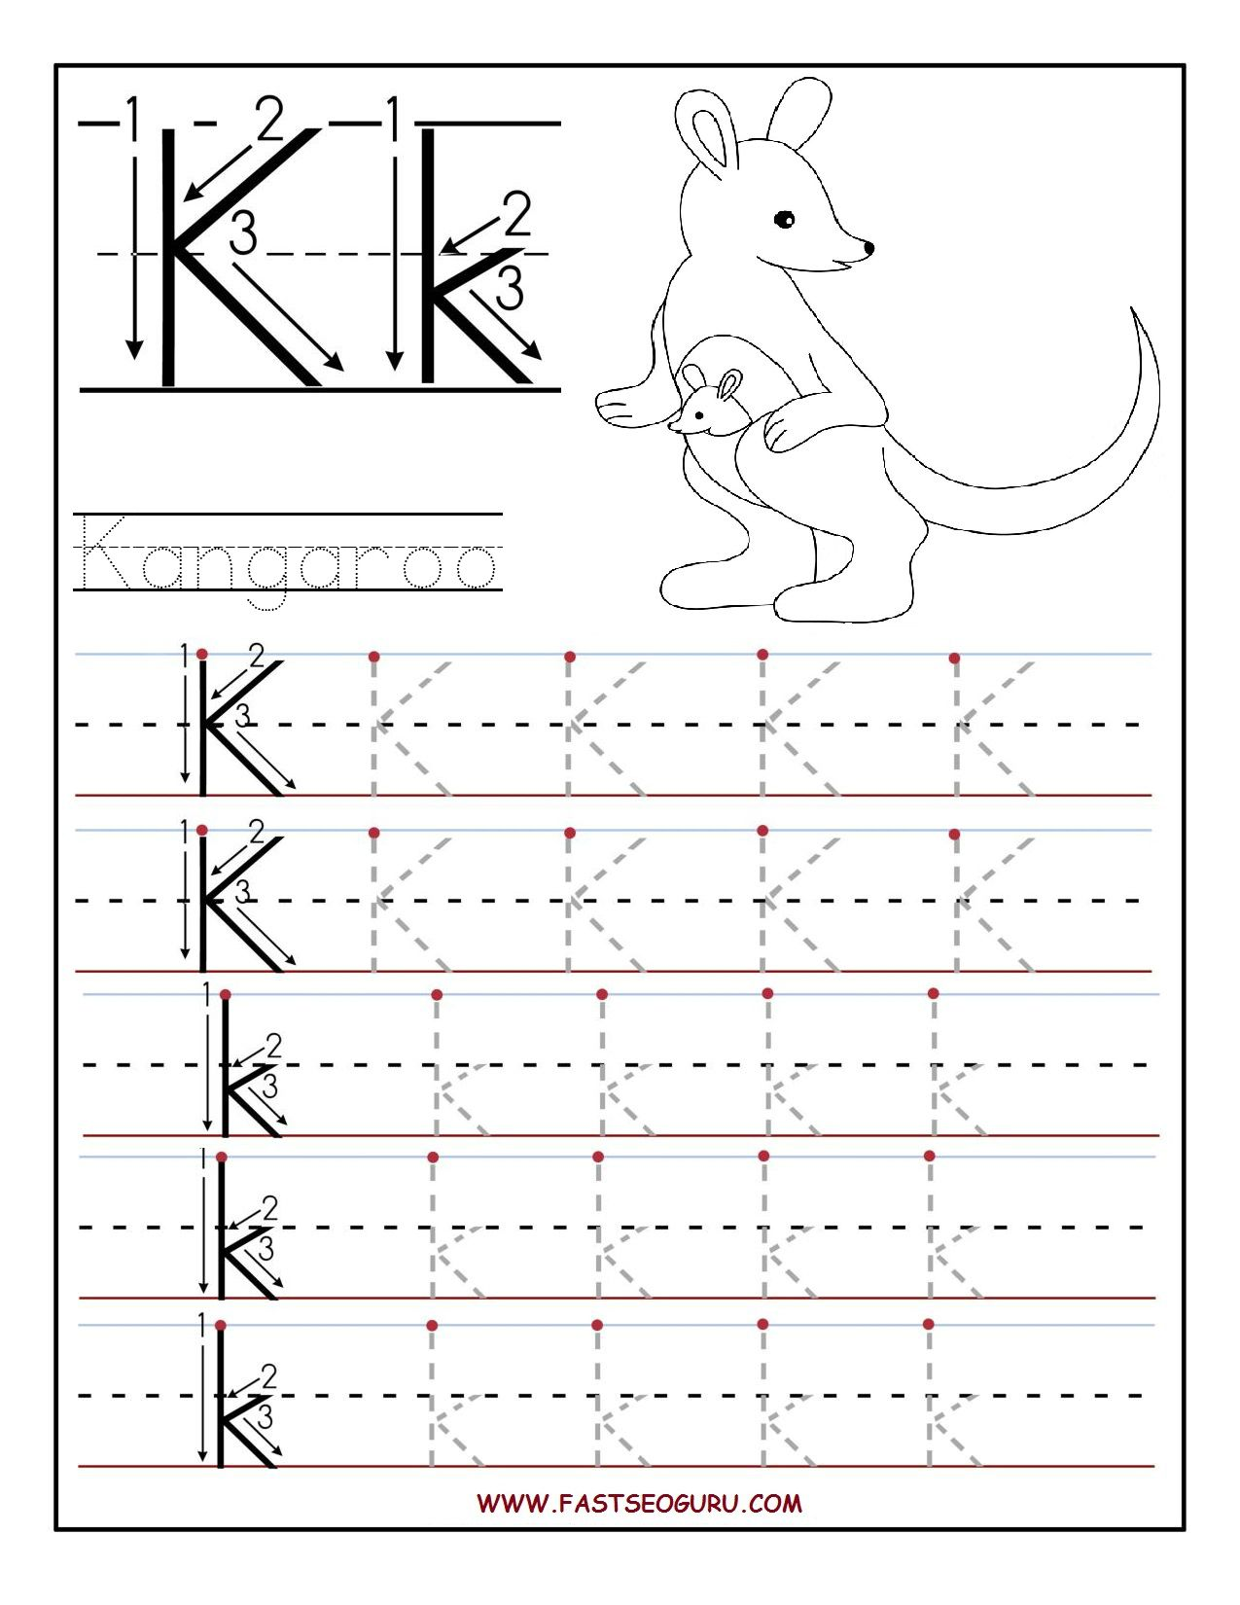

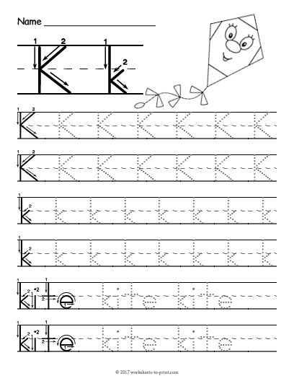



Name___________________ Date___________

