Make a Rainbow Fish
Time to get out your craft materials again……Find some paper, cardboard (cereal boxes or paper plates), paint, felt pens and make your own rainbow fish. Get all your family busy too. Here are some ideas……

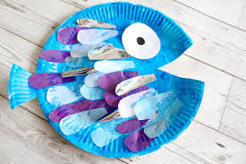 | Use a paper plate or a circle cut out from a cereal box to make this rainbow fish.
How many different coloured pieces of paper can you stick on your rainbow fish?. | 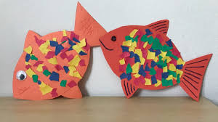
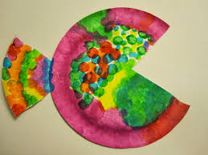 | Use paints in rainbow colours.
Here’s another painted rainbow fish. | 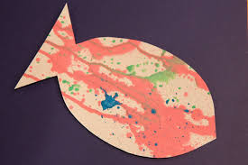
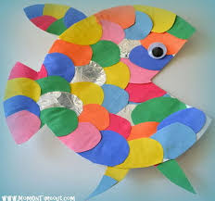 | And another one made from a circle of card or a paper plate.

If you have some playdough, try using that to make a rainbow fish.
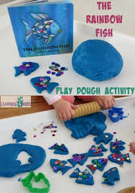
Have fun!

