Make an Octopus
Time to get out your craft materials again……Find some paper, cardboard (cereal boxes or paper plates), paint, felt pens and make an octopus. Get all your family busy too. Here are some ideas……

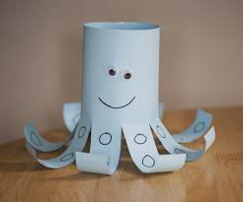 | This is made from a tube of card. Make cuts half-way along and curl the strips for arms.
This is made from a paper bag. | 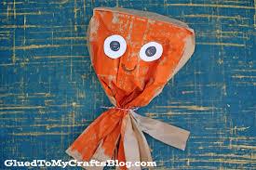
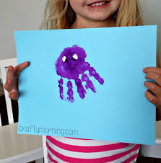 | Make a print with your hands using paint, or cut out the shape of your hand from paper.
This is an octopus made from a paper plate. | 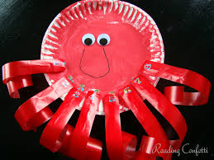
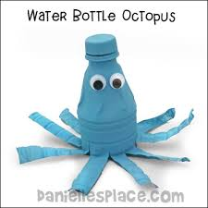 | This is made from the top of a plastic bottle. Ask an adult to cut it for you.

If you have some playdough, try using that to make an octopus.

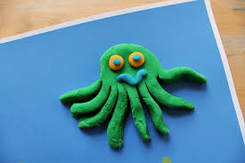

Have fun!

