Name___________________ Date____________

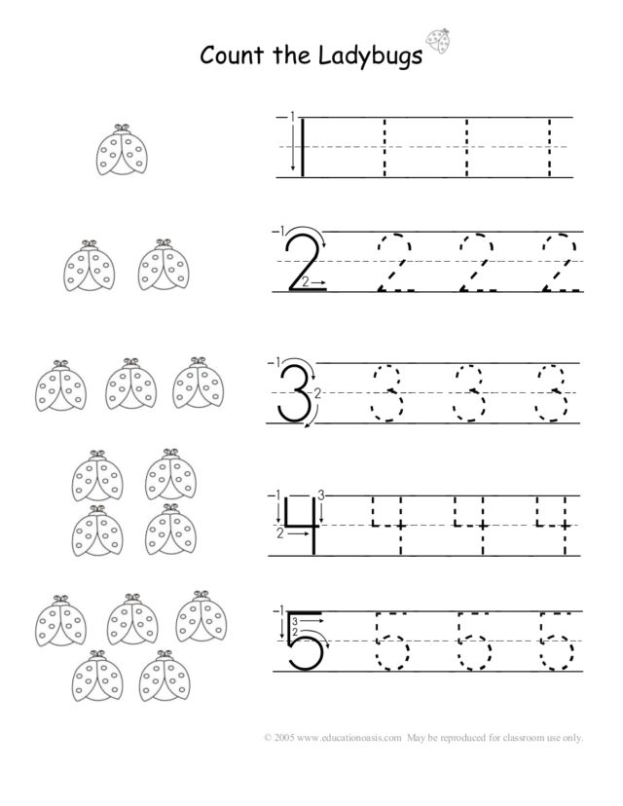

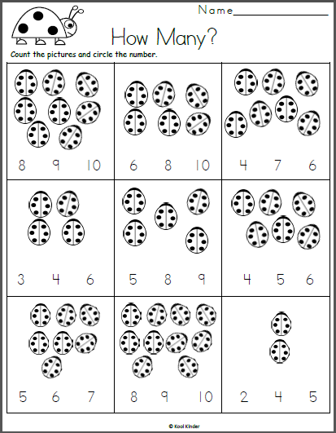

Write how many spots on each wing. Add the spots.

