O is for Octopus
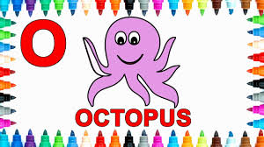

Watch the song here
https://www.youtube.com/watch?v=ce-WOfylKow

O is for octopus…………

- Can you think of 5 words beginning with O?
- 8 words?
- Any more?
- Ask your family to think too.
- Can you find or draw pictures of some of them?
- Maybe someone could write a list……

