R is for Rainbow and F is for Fish

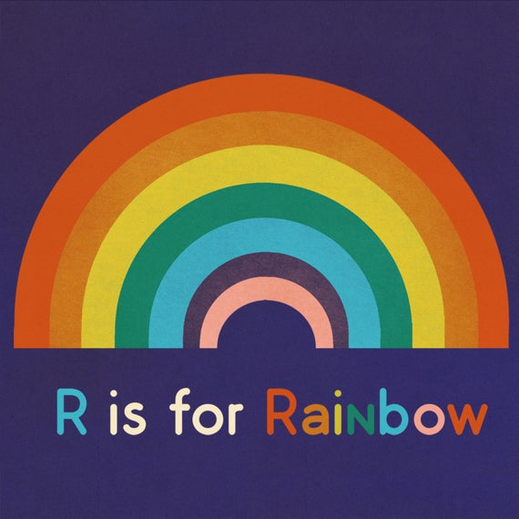
R is for Rainbow
Watch a video here:
https://www.youtube.com/watch?v=T08v1Z7r-qs

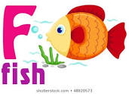
and F is for Fish…………
Watch another video here:
https://www.youtube.com/watch?v=T08v1Z7r-qs

- Can you find things in your home that start with a R sound?
- And things that start with a F sound?
- Ask your family to think too.
- Can you find or draw pictures of some of them?
- Maybe someone could write a list……

