Soapy sea foam
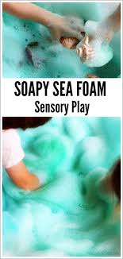
Have fun making and playing with sensory sea foam!

Soapy sea foam
- Place 2 tablespoons of body wash suitable for your child’s skin and 2 tablespoons of water in a large bowl.
- Add 1 tablespoon of cornflour and a squirt of washable poster paint or food colouring (you choose the colour!)
- Mix together using an electric whisk (or a hand whisk) for a couple of minutes at high speed.
- Soon, you will have lots of soft bubbly foam ready to play with.

Watch these videos to inspire you:

https://www.youtube.com/watch?v=Bobuj5Mgd7A

https://www.youtube.com/watch?v=MzkE7KthOZY

