The Rainbow Fish

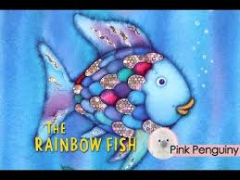
The Rainbow Fish learns that sharing can give you a good feeling.
Use the links below to listen to the story of the Rainbow Fish.

https://www.youtube.com/watch?v=Nb2msIQo6TI
https://www.youtube.com/watch?v=QFORvXhub28
https://www.youtube.com/watch?v=Z3cmddZh6t8

You can also hear the story of Rainbow Fish to the Rescue using the link below.
https://www.youtube.com/watch?v=Gja_mMXU4ao

