REMOTE LEARNING POLICY
Sept 2020


Watergate School
Remote Learning Policy

1. Aims
This remote learning policy for staff aims to:
- Ensure consistency in the approach to remote learning for pupils who aren’t in school
- Set out expectations for all members of the school community with regards to remote learning
- Provide appropriate guidelines for data protection

2. Remote Learning for Watergate Pupils
We recognise that our pupils are not yet independent, autonomous learners. Therefore, any learning that takes place at home will rely on the engagement and commitment of family members. It is our role to engage with, enthuse, enable and empower families to be able to deliver home learning wherever possible.
In order for remote learning to be meaningful and relevant for pupils, it will comprise of a dual tiered approach:
Individual Education Plans (IEPs) – termly - learning objectives set by teachers in close liaison with parents and other professionals, linked to each child’s EHCP outcomes and Steps Towards. Personalised home learning plans will accompany IEPs giving ideas for learning activities at home and links to videos and information sheets, supporting families to learn and use a range of appropriate teaching strategies at home.
Home Learning Challenges - weekly - each class group will have a sheet of home learning challenges linked to the term’s topic. All areas of the Watergate curriculum will be represented in the challenges so that pupils can continue to engage in a broad range learning whilst at home.
When will the various aspects of remote learning take effect?
 | If an individual pupil is self-isolating for 10 or 14 days or is shielding (but is well) and the rest of their class is in school | If the bubble (class group) is self-isolating but the rest of the school is open | If the whole school is self-isolating | In the event of a longer lockdown
Individual Education Plan with Personalised Home Learning Plan | 
Home Learning Challenges sent out via email
Home Learning Challenges available on class webpage
Home Learning ‘How to…’ guides available on school website
Class teachers available for support via class specific email and Zoom (where previously arranged)
Additional online resources linked to Home Learning Challenges available on class webpages
Fortnightly phone calls home

3. Roles and responsibilities
3.1 Teachers
When providing remote learning during their bubble or wider school self-isolation or in the event of a longer period of lockdown, teachers must be available between 8:45am and 3:45pm (with the exception of a lunch break).
If they are unable to work for any reason during this time, for example due to sickness, they should report this using the normal absence procedure.
When providing remote learning, teachers are responsible for:
- Setting work:
  - Individual Education Plans must be agreed and set in liaison with parents and other professionals by the fourth week of the Autumn Term and the third week of each term thereafter.
  - Personalised Home Learning Plans must be completed ready to send home to families with the IEPs following the Teaching, Learning and Assessment Framework 20-21
  - Weekly Home Learning Challenges sheets linked to the termly topic should reflect similar (if not the same) learning activities which have been or would have been planned for if the pupils were in school. Teachers must ensure that there are Home Learning Challenges linked to each of the areas of the Watergate curriculum. One Home Learning Challenges sheet per class per week.
  - Weekly Home Learning Challenge sheets must be completed and emailed to the member of the senior leadership team linked to your class by 2pm on Thursday for the following week.
  - Weekly Home Learning Challenge sheets should be emailed to parents by 3:30pm on Friday for the following week (once checked by SLT)
  - Where teachers are providing additional learning resources (such as videos or links to online events) these can be emailed to the member of SLT linked to their class for uploading onto the class webpage
  - In the event of whole school self-isolation or a longer period of lockdown, teachers can work together in groups set out below in order to allocate tasks (such as setting Home Learning Challenges for specific areas of the curriculum or creating videos to support learning) so that they are able to share the workload. Teachers can communicate and decide on the allocation of tasks by work email.
  - Teacher groups (by class names):
Chestnut, Sky and Olive
Red and Blue | Yellow and Green | Pink and Orange
Violet and Gold | Silver and Peach | Lime and Aqua
Purple – to provide support regarding MOVE and Physical Development

- Providing feedback on work:
  - Where parents and pupils send work or report on learning undertaken at home, teachers will be expected to respond to this with 24hours (during working hours) in a format that they feel is most appropriate – this may be via a written email response, a voice message or short video message
  - Any feedback given must comply with the expectations for professional working
- Keeping in touch with pupils who are not in school and their parents:
  - Teachers should use class specific email accounts to send resources and respond to parents/pupils
  - Where individual pupils are self-isolating or shielding, all possible attempts should be made to provide opportunities for virtual engagement in appropriate class activities – for example, class greeting, music session, singing session, story, etc. This can be arranged with parent beforehand.
  - Teachers should aim to respond to emails from parents within 24hours, but are not expected to do so outside of working hours or at weekends.
  - Complaints or concerns from parents via phone or email, should be shared as soon as possible with a member of the senior leadership team. Teachers should seek advice before responding to parents.
  - Where teachers have safeguarding concerns, these must be recorded on CPOMS as soon as possible with the safeguarding team alerted via CPOMS (see safeguarding section below)
  - Guidance for Special Schools Special Post-16 Provision and Alternative Provision, issued 14th January 2021, states that: “All settings should have systems for checking, daily, whether pupils and students are engaging with their work, and work with families to rapidly identify effective solutions where engagement is a concern.”
Teachers should allocate responsibility to their class teams in order to ensure daily contact is made. Whatever system is put in place teachers must ensure that they have contact with each family at least once a week. Contact is to be recorded on CPOMS
- Attending virtual meetings with staff, parents and pupils:
  - As with face to face meetings in school, teachers are expected to maintain all professional expectations during virtual meetings, including appropriate dress code, suitable background during virtual meetings, finding a suitably quiet area in which to join meetings virtually, etc.
3.2 Higher Level Teaching Assistants (HLTAs) and Senior Nursery Nurses (SNNs)
If HLTAs or SNNs are unable to work remotely for any reason during this time, for example due to sickness, they should report this using the normal absence procedure.
When assisting with remote learning, HLTAs and SNNs are responsible for:
- Providing Home Learning Challenges for the curriculum area(s) they would usually plan for and deliver at school during the week (e.g.; during a teachers PPA time).
- These activities need to be submitted to teachers by Wednesday 3:30pm for the following week.
- In the event of their bubble self-isolating or a longer period of lockdown, HLTAs and SNNs are expected to provide additional home learning resources (such as videos or links to online events) linked to the Home Learning Challenges they have set each week.
- There is no expectation that additional home learning resources should be created or provided by HLTAs or SNNs who continue to work in school.
- Additional home learning resources described above should be emailed to the member of Senior Leadership Team linked to your class (see below) by email. These will be uploaded to the class webpage within 24 hours of being received.
3.3 Curriculum leads
Alongside their teaching responsibilities, in the event of a longer period of lockdown, subject leads are responsible for:
- Monitoring the remote work set by teachers in their subject to ensure that work set is appropriate and consistent.
- Issues arising should be addressed in a supportive and solution-focused manner via email, phone or Zoom meeting as appropriate with the teacher
- Best practice ideas should be recognised and shared with colleagues
- Alerting teachers to resources they can use to teach their subject remotely
3.4 Senior leaders
Senior leaders are responsible for:
- Co-ordinating the remote learning approach across the school – Natalie Carroll, DHT
- Monitoring the quality of Home Learning Challenges provided by teachers (in the classes allocated to each member of the SLT) prior to Home Learning Challenges sheets being uploaded to class webpages or being emailed to parents.
- Monitoring the quality and appropriateness of any additional learning resources provided by teachers prior to these being uploaded to the website
- Where the quality of remote learning needs to be addressed, this should be done with the class teacher responsible by telephone, email or Zoom meeting.
- Uploading Home Learning Challenge sheets onto class webpages by 3:30pm on Friday for the following week
- Uploading additional home learning resources sent to them by teachers onto class webpages within 24 hours of receiving them
3.5 Designated safeguarding lead
The DSL is responsible for:
- Monitoring the security of remote learning systems, including data protection and safeguarding considerations
- Responding to all concerns from staff or families that are raised as a result of home learning interventions.
3.6 IT staff (Deku)
Deku are responsible for:
- Fixing issues with systems used to set and collect work
- Helping staff and parents with any technical issues they’re experiencing
- Reviewing the security of remote learning systems and flagging any data protection breaches to the data protection officer
3.7 Parents
Staff can expect parents with children learning remotely to:
- Make the school aware if their child is sick or otherwise can’t complete work, by calling the school office on 0208 695 6555
- Seek help from the school if they need it, initially with teachers via class specific email addresses (see below)
- Be respectful when making any complaints or concerns known to staff
3.8 Governing body
The governing body is responsible for:
- Monitoring the school’s approach to providing remote learning to ensure education remains as high quality as possible
- Ensuring that staff are certain that remote learning systems are appropriately secure, for both data protection and safeguarding reasons

4. Who to contact

If parents have any questions about remote learning set by class teachers or require any support or advice about home learning, they should, in the first instance, contact the class teacher by email using the class specific email for their child’s class group:
 | Sky Class: sky@watergate.lewisham.sch.uk | Olive Class:  olive@watergate.lewisham.sch.uk
Red Class: red@watergate.lewisham.sch.uk | Green Class: green@watergate.lewisham.sch.uk | Yellow Class: yellow@watergate.lewisham.sch.uk
Blue Class: blue@watergate.lewisham.sch.uk | Purple (MOVE information): purple@watergate.lewishm.sch.uk | Violet Class: violet@watergate.lewisham.sch.uk
Pink Class: pink@watergate.lewisham.sch.uk | Orange Class: orange@watergate.lewisham.sch.uk | Silver Class: silver@watergate.lewisham.sch.uk
Peach Class: peach@watergate.lewisham.sch.uk | Lime Class: lime@watergate.lewisham.sch.uk | Aqua Class: aqua@watergate.lewisham.sch.uk
Gold Class:
gold@watergate.lewisham.sch.uk

If staff have any questions or concerns about remote learning, they should contact the following individuals:
- Issues in setting work – contact the member of senior leadership team linked to your class group (see below)
- Issues with IT – contact Deku via email and copy in SLT
- Issues with their own workload or wellbeing – contact the member of senior leadership team linked to your class group (see below)
- Concerns about data protection – contact Carly Kennedy c.kennedy@watergate.lewisham.sch.uk
- Concerns about safeguarding – contact Fiona Veitch (DSL), headteacher@watergate.lewisham.sch.uk
- Advice and support for families – contact Rani Singh, Family Support Worker r.singh@watergate.lewisham.sch.uk

Class group | Member of SLT allocated to class & contact details
Chestnut, Sky, Olive, Lime | Natalie Carroll n.carroll-ward@watergate.lewisham.sch.uk
Green, Yellow, Blue, Purple | Fiona Veitch headteacher@watergate.lewisham.sch.uk
Violet, Pink, Orange, Silver | Linda Matthews l.matthews@watergate.lewisham.sch.uk
Peach, Aqua, Gold, Red | Clare Chalaye c.chalaye@watergate.lewisham.sch.uk

5. Data protection
5.1 Accessing personal data
When accessing personal data for remote learning purposes:
- Access information using secure connections on laptops provided by the school, e.g.; using CPOMS or by email communications with the Admin Team.
- Personal data should not be stored on teachers’ personal devices or written down. Any stored information should remain on password protected school devices.
5.2 Processing personal data
Staff members may need to collect and/or share personal data such as email addresses or telephone numbers as part of the remote learning system. As long as this processing is necessary for the school’s official functions, individuals won’t need to give permission for this to happen.
However, staff are reminded to collect and/or share as little personal data as possible online.
5.3 Keeping devices secure
All staff members will take appropriate steps to ensure their devices remain secure. This includes, but is not limited to:
- Keeping the device password-protected – strong passwords are at least 8 characters, with a combination of upper and lower-case letters, numbers and special characters (e.g. asterisk or currency symbol)
- Ensuring the hard drive is encrypted – this means if the device is lost or stolen, no one can access the files stored on the hard drive by attaching it to a new device
- Making sure the device locks if left inactive for a period of time
- Not sharing the device among family or friends
- Installing antivirus and anti-spyware software
- Keeping operating systems up to date – always install the latest updates

6. Safeguarding
The Safeguarding Policy is available on the school website at:
https://www.watergate.lewisham.sch.uk/parents-zone/safeguarding/

7. Monitoring arrangements
This policy will be reviewed at least annually. At every review, it will be approved by the Head Teacher and Governing Body (Education and Welfare Committee).

8. Links with other policies
This policy is linked to our:
- Behaviour policy
Safeguarsing and Child Protection Policy and coronavirus addendum to our Safeguarding and Child Protection Policy
- Data protection policy and privacy notices
- ICT and internet acceptable use policy
- Online safety policy

9. Appendices
A: Personalised Home Learning Plan template
B: Personalised Home Learning Plan exemplar
C: Home Learning Challenges template
D. Home Learning Challenges example 1
E: Home Learning Challenges example 2

Approved by: | F. Veitch Headteacher | Date: 1/10/20
Last reviewed on: | 11 January 2021
Next review due by: | 30 January 2021

Appendix A: Personalised Home Learning Plan template
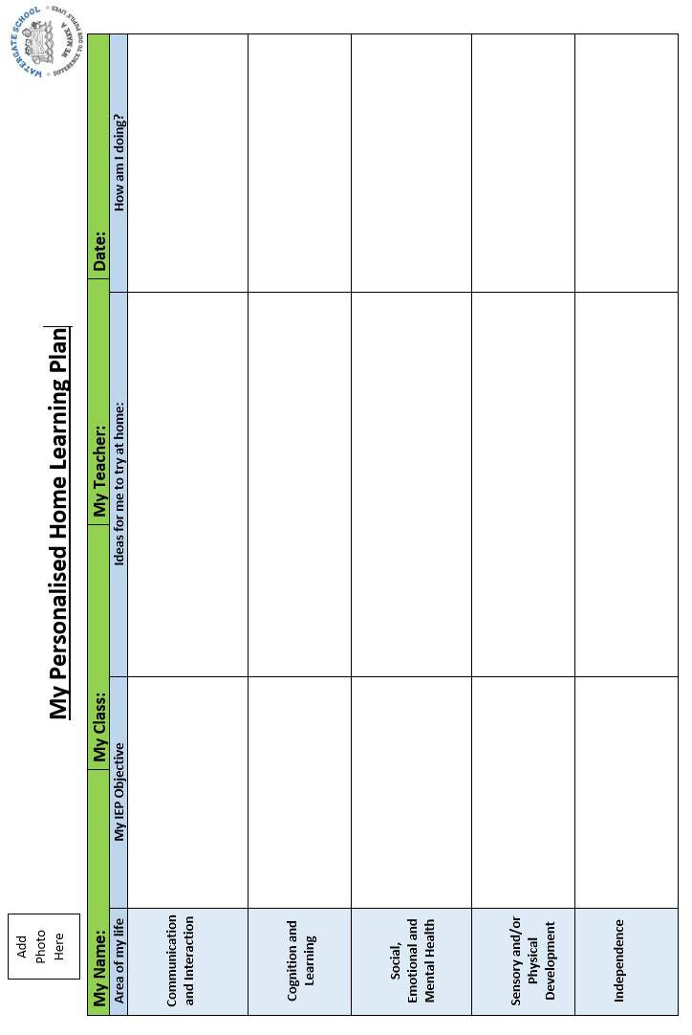

Appendix B: Personalised Home Learning Plan exemplar
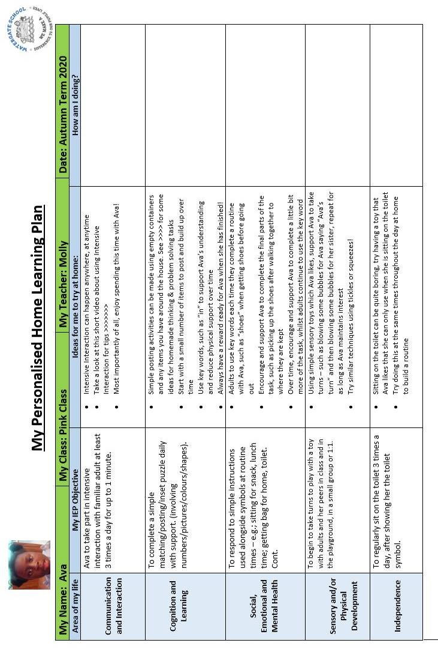
Appendix C: Home Learning Challenges template
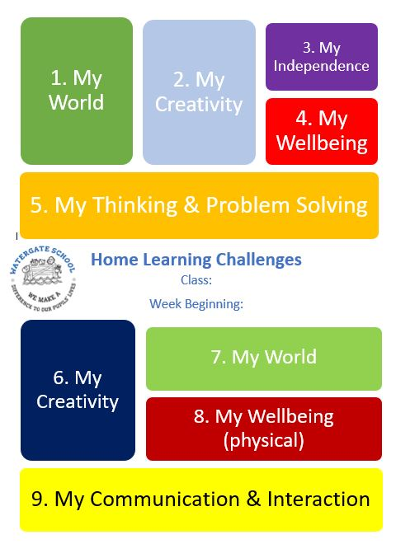
Appendix D: Home Learning Challenges example 1
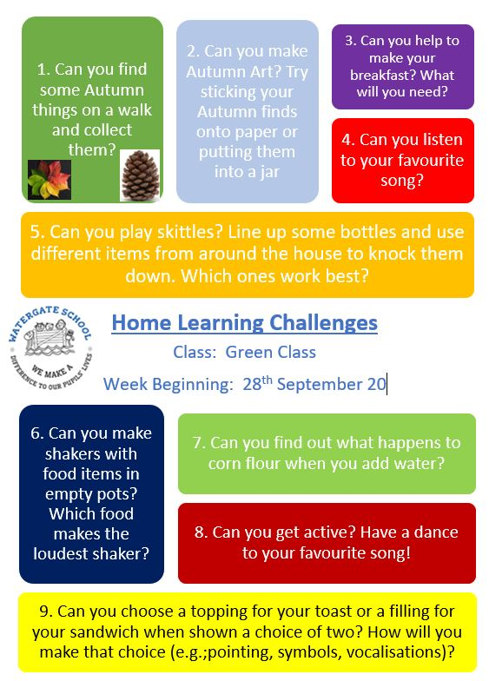

Appendix E: Home Learning Challenges example 2


